|  |  |
| --- | --- |
| Logo_FPT_University_doc | **MINISTRY OF EDUCATION AND TRAINING** |

**FPT UNIVERSITY**

**CAPSTONE PROJECT DOCUMENT**

BSMS

**Report #4 – Software Design Specification**

|  |  |
| --- | --- |
|  | |
| Group Member | SE03975 - Olasehinde Ezekiel Olaoluwa |
| SE\*\*\*\*\* - Kanda Joshua David |
| SE\*\*\*\*\* - Shunom Peter Bala |
| Supervisor | Bui Đinh Chien |
| Ext. Supervisor |  |
| Project Code | BSMS |

- Hanoi, 05/2012 -

Table of Contents

[1 PURPOSE 4](#_Toc483851876)

[2 ARCHITECTURE DESIGN 4](#_Toc483851877)

[2.1 Choice of Architecture Design 4](#_Toc483851878)

[2.1.1 Our System Architecture 4](#_Toc483851879)

[2.1.2 ASP.NET MVC ARCHITECTURE 5](#_Toc483851880)

[2.2 Architectural Presentation 6](#_Toc483851881)

[2.3 Component/Package Design 7](#_Toc483851882)

[3 DETAILED DESIGN 7](#_Toc483851883)

[3.1 Common Design 7](#_Toc483851884)

[3.2 Authentication Management 7](#_Toc483851885)

[3.2.1 Class Diagram 7](#_Toc483851886)

[3.2.2 Class Description 7](#_Toc483851887)

[3.2.3 Register Customer/Staff 9](#_Toc483851888)

[3.2.4 Login 11](#_Toc483851889)

[3.2.5 Logout 13](#_Toc483851890)

[3.2.6 Forget Password 14](#_Toc483851891)

[3.3 Category Management 14](#_Toc483851892)

[4 DATABASE DESIGN 15](#_Toc483851893)

[4.1 Entity Relationship Diagram 15](#_Toc483851894)

[4.2 Database Diagram 16](#_Toc483851895)

[4.3 Table Descriptions 16](#_Toc483851896)

[4.3.1 User 16](#_Toc483851897)

[4.3.2 Role 17](#_Toc483851898)

[4.3.3 Author 17](#_Toc483851899)

[4.3.4 Category 18](#_Toc483851900)

[4.3.5 Genre 18](#_Toc483851901)

[4.3.6 Book 19](#_Toc483851902)

[4.3.7 Book\_Category 20](#_Toc483851903)

[4.3.8 Producer 20](#_Toc483851904)

[4.3.9 Book\_SoftCopy 20](#_Toc483851905)

[4.3.10 Book\_Author 21](#_Toc483851906)

[4.3.11 WatchList 21](#_Toc483851907)

# PURPOSE

This document is proposed with intent of describing the technical design of our bookstore Management system, mainly to give development team an overall overview of the system’s architecture, thus bringing them to a level of enlightenment of how the system should work and how to implement it. This section contains the following

* System Architecture Design
* Database Design
* Detail Design

# ARCHITECTURE DESIGN

## Choice of Architecture Design

### Our System Architecture

BSMS web application uses the MVC (Model-View and Controller) architecture together with ASP.NET Web Services (XML,JSON), which has been one of the best software design pattern this days, This will allow our code to be more readable, more understandable and editable than the native coding pattern.

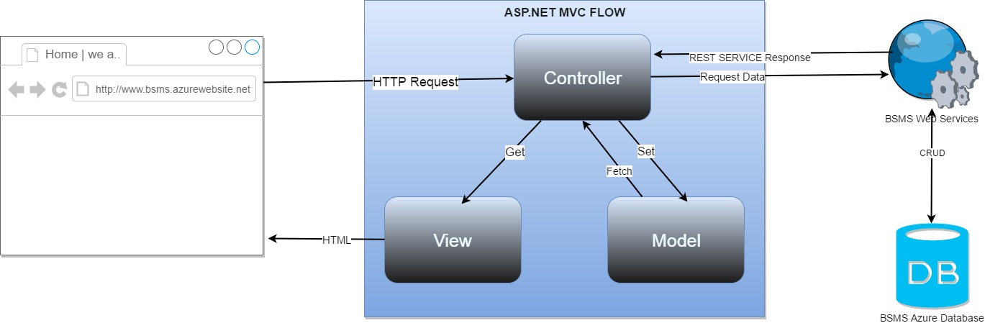

* **Models :** Model objects are the parts of the application that implement the logic for the application's data domain. Often, model objects retrieve and store model state in a database. For example, a Product object might retrieve information from a database, operate on it, and then write updated information back to a Products table in a SQL Server database.

In small applications, the model is often a conceptual separation instead of a physical one. For example, if the application only reads a dataset and sends it to the view, the application does not have a physical model layer and associated classes. In that case, the dataset takes on the role of a model object.

In Our system the model will be referencing to the BSMS web service to complete database related tasks.

* **Views :** Views are the components that display the application's user interface (UI). Typically, this UI is created from the model data. An example would be an edit view of a Products table that displays text boxes, drop-down lists, and check boxes based on the current state of a Product object..
* **Controllers :** This serves as the system handler, it handles user input and what the system do with them. When request is send from the client side the asp.net send a request to the controller, which after the controller will find the equivalent get method and them render the called view.

 Controllers are the components that handle user interaction, work with the model, and ultimately select a view to render that displays UI. In an MVC application, the view only displays information; the controller handles and responds to user input and interaction. For example, the controller handles query-string values, and passes these values to the model, which in turn might use these values to query the database**.**

* **Web Service**: This is the service that connects to the database and fetches data for the controller to make use of; CRUD methods will be implemented using this web service.

### FEATURES OF THE ASP.NET MVC FRAMEWORK

* Separation of application tasks (input logic, business logic, and UI logic), testability, and test-driven development (TDD). All core contracts in the MVC framework are interface-based and can be tested by using mock objects, which are simulated objects that imitate the behavior of actual objects in the application. You can unit-test the application without having to run the controllers in an ASP.NET process, which makes unit testing fast and flexible. You can use any unit-testing framework that is compatible with the .NET Framework.
* An extensible and pluggable framework. The components of the ASP.NET MVC framework are designed so that they can be easily replaced or customized. You can plug in your own view engine, URL routing policy, action-method parameter serialization, and other components. The ASP.NET MVC framework also supports the use of Dependency Injection (DI) and Inversion of Control (IOC) container models. DI enables you to inject objects into a class, instead of relying on the class to create the object itself. IOC specifies that if an object requires another object, the first objects should get the second object from an outside source such as a configuration file. This makes testing easier.
* Extensive support for ASP.NET routing, which is a powerful URL-mapping component that lets you build applications that have comprehensible and searchable URLs. URLs do not have to include file-name extensions, and are designed to support URL naming patterns that work well for search engine optimization (SEO) and representational state transfer (REST) addressing.
* Support for using the markup in existing ASP.NET page (.aspx files), user control (.ascx files), and master page (.master files) markup files as view templates. You can use existing ASP.NET features with the ASP.NET MVC framework, such as nested master pages, in-line expressions (<%= %>), declarative server controls, templates, data-binding, localization, and so on.
* Support for existing ASP.NET features. ASP.NET MVC lets you use features such as forms authentication and Windows authentication, URL authorization, membership and roles, output and data caching, session and profile state management, health monitoring, the configuration system, and the provider architecture.

## Component Diagram

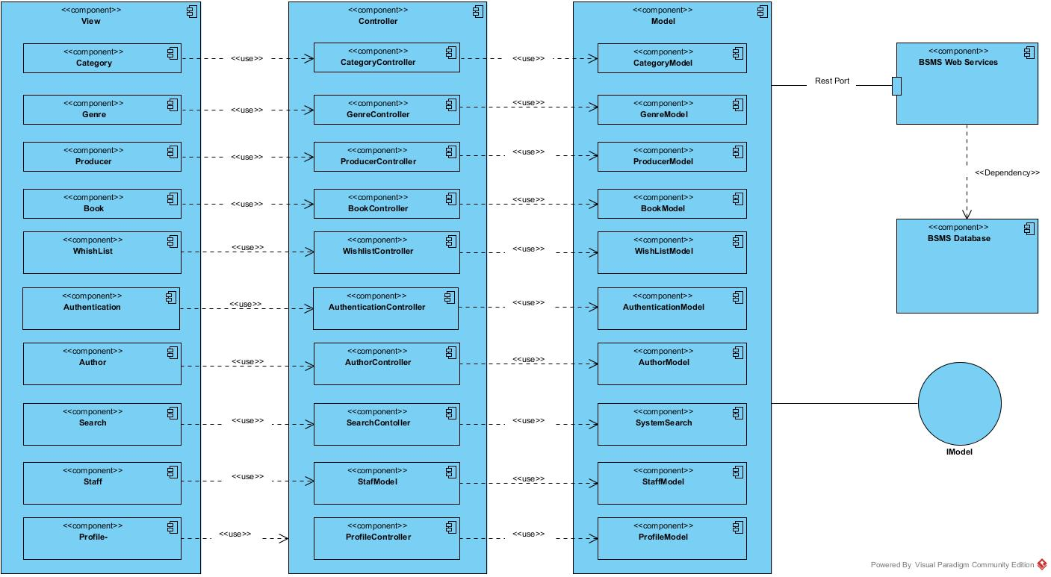

# DETAILED DESIGN

## Common Design

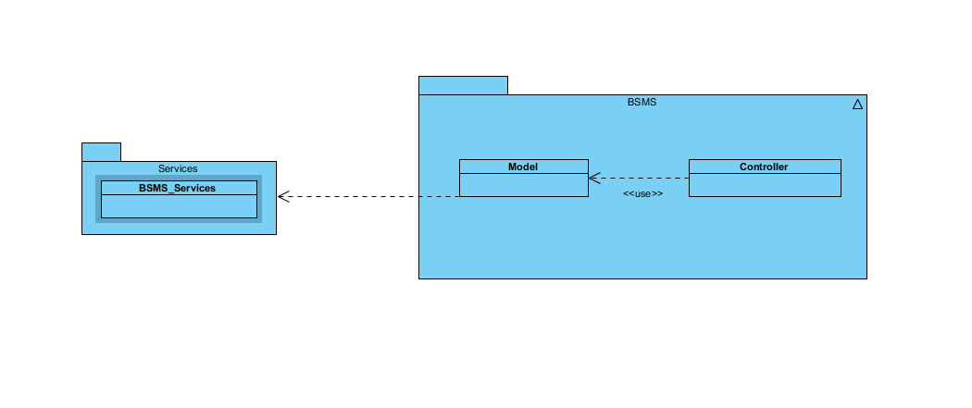

## Authentication Management

### Class Diagram

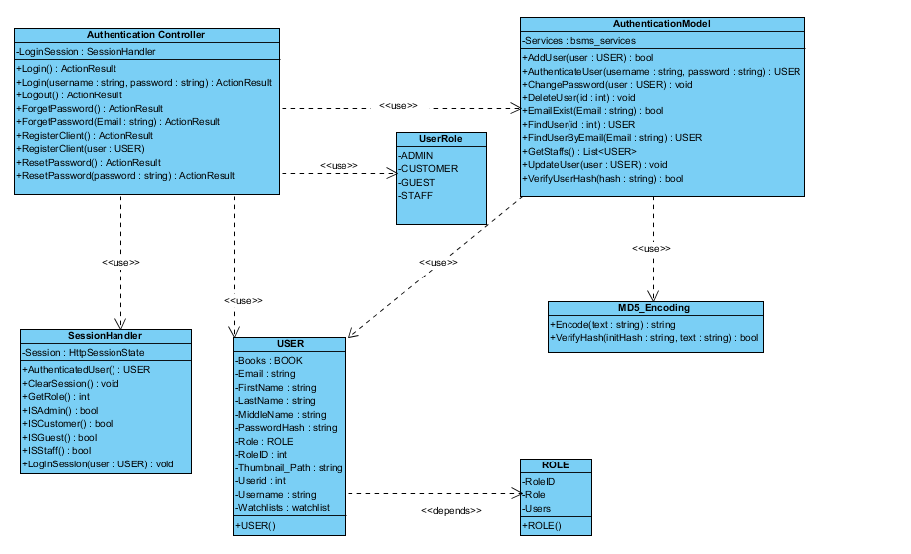

### Class Description

|  |  |  |
| --- | --- | --- |
| Class | Dependency | Description |
| User | Role | The user class holds all user data and information including all the usernames and passwords in the system, this is known as the BSMS user recognition methodology. |
| Role | N/A | This class is intended to hold unique set of roles for users, since the user uses this class as dependency, user has a role, which is how the system recognise the type of user coming into the system |
| AuthenticationController | N/A | Controller class which extends from the base class system.web.muvc controller, this class handles all http request including http post and get, delete method. |
| SessionHandler | N/A | This class acts as session assistant, in other words this class handles all session related activities |
| AuthenticationModel | USER | This is a class that handles all operations that involves Authentication including CRUD Operations, thus this class have direct connection to BSMS SOAP Webservices. |
| MD5\_Encoding | N/A | This class handles encoding, like encode, decode |
| UserRole | N/A | This class acts like enum class, as this keeps static variables of each types of users that exist in the system |

#### User

|  |  |  |  |  |
| --- | --- | --- | --- | --- |
| Class | User | | | |
| **Description** | User data, this class holds all the user information including the password and username | | | |
| **Base Class** | Authentication | | | |
| **Constructor** | Default | | | |
| **Prototype** |  | | | |
| **Source File** | User.cs | | | |
| **Namespace** | BSMS.Model | | | |
| **Attributes** | Name | Type | Description | |
| Name | String | N/A | |
| Username | String | Users username is contained in this attribute | |
| PasswordHash | String | This contains 64 digit MD5 encrypted password | |
| Email | String |  | |
| RoleID | int | This hold the role of user in number format ex. (1:”Staff” , 2:”Admin”) | |
|  | Thumbnail | String | This hold the thumbnail path in the system | |
| **Methods** | Name | Input | Output | Description |
| Authentication | Username  Password | User | This function check if user is valid or not, returns null if not valid and user information if valid |
| LoggedOn | N/A | Boolean | This function is intended to check if any user is logged on to the system |

#### Role

|  |  |  |  |
| --- | --- | --- | --- |
| Class | Role | | |
| **Description** | This contain all the user roles that exists in the system | | |
| **Base Class** | N/A | | |
| **Constructor** | Default | | |
| **Prototype** |  | | |
| **Source File** | Role.cs | | |
| **Namespace** | BSMS.Model | | |
| **Attributes** | Name | Type | Description |
| Roleid | int | This is a unique integer value that holds a unique id for each role that exist in the system |
|  | Role | String | Name of this role e.g “Admin” |

#### Authentication Controller

|  |  |  |  |  |
| --- | --- | --- | --- | --- |
| Class | AuthenticationController | | | |
| **Description** | Controller class which extends from the base class system.web.muvc controller, this class handles all http request including http post and get, delete method. | | | |
| **Base Class** | System.Web.Mvc.Controller | | | |
| **Constructor** | N/A | | | |
| **Prototype** |  | | | |
| **Source File** | AuthenticationController.cs | | | |
| **Namespace** | BSMS.Controller | | | |
| **Methods** | Name | Input | Output | Description |
| Login | N/A | ActionResult | This method make a request to the Http Get in order to request for a page |
| Login | String, String | ActionResult | This method call makes request to Http Post and calls the Authentication Model class to verify user detail |
| Logout | N/A | ActionResult | On this method call E-U will be logged out of the system and redirect to the login page |
| ForgetPassword | N/A | ActionResult | Http Method call to request forget password page |
| ForgetPassword | String | ActionResult | Http Post method call to act on user input |
| RegisterUser | N/A | ActionResult | Request made to register user or customer page |
| RegisterUser | User | ActionResult | Process new user Http Post method |

#### Session Handler

|  |  |  |  |  |
| --- | --- | --- | --- | --- |
| Class | SessionHandler | | | |
| **Description** | This class acts as session assistant, in other words this class handles all session related activities | | | |
| **Base Class** | N/A | | | |
| **Constructor** | Default | | | |
| **Prototype** |  | | | |
| **Source File** | SessionHandler.cs | | | |
| **Namespace** | BSMS.Session | | | |
| **Attributes** | Name | Type | Description | |
| Session | HttpSessionState | The Session is an instance of the HttpSessionState, which contains the application context Session | |
| **Methods** | Name | Input | Output | Description |
|  | AuthenticatedUser | N/A | USER | This method return the currently logged in user, and returns it’s object |
| ClearSession | N/A | N/A | This method is used to clear application context session |
| GetRole | N/A | Integer | This method will be used to get role of currently loggeduser |
| ISAdmin | N/A | Boolean | This method is mean’t to check if currently logged in user is Admin |
| ISCustomer | N/A | Boolean | This method is mean’t to check if currently logged in user is Customer |
| ISGuest | N/A | Boolean | This method is mean’t to check if there is no logged user in the system |
| ISStaff | N/A | Boolean | This method is mean’t to check if currently logged in user is Staff |
| LoginSession | USER | N/A | This method is mainly used to create a login session, which mean this will be used only when users’ needs to login. |

#### Authentication Model

|  |  |  |  |  |
| --- | --- | --- | --- | --- |
| Class | AuthenticationModel | | | |
| **Description** | This is a class that handles all operations that involves Authentication including CRUD Operations, thus this class have direct connection to BSMS SOAP Webservices. | | | |
| **Base Class** | N/A | | | |
| **Constructor** | Default | | | |
| **Prototype** |  | | | |
| **Source File** | Authentication.cs | | | |
| **Namespace** | BSMS.Model | | | |
| **Attributes** | Name | Type | Description | |
| Services | bsms\_services | This is a private instance of “BSMS.SERVICES” | |
| **Methods** | Name | Input | Output | Description |
| AddUser | USER | Boolean | This method is use to call the webservices method inorder to add a new user into the system |
| AuthenticateUser | String, String | USER | This method is proposed to check if login credential is correct or not, this return null if username or password is incorrect and User Object otherwise |
| ChangePassword | USER | N/A | This method is used to change user passwords on reset password request |
| DeleteUser | Int | N/A | This static method is used to delete user from BSMS |
| FindUser | Int | USER | This static method return User Object which matches the id of user inpt |
| FindUserByEmail | Int | USER | This method is used to find user by email, since the email address of each user is unique |
| GetStaffs | N/A | List<USER> | This method is used to get all avaliable staff in the system |
| UpdateStaff | USER | N/A | This is used to update staff informations |
| VerifyUserHash | String | Boolean | This method is mainly used to verify hash code of users |

#### MD5\_Encoding

|  |  |  |  |  |
| --- | --- | --- | --- | --- |
| Class | MD5\_Encoding | | | |
| **Description** | This class handles encoding, like encode, decode | | | |
| **Base Class** | MD5\_Encoding | | | |
| **Constructor** | Default | | | |
| **Prototype** |  | | | |
| **Source File** | MD5\_Encoding.cs | | | |
| **Namespace** | BSMS.Model | | | |
| **Methods** | Name | Input | Output | Description |
| Encode | String | String | This function mainly encode input string to MD5 encryption |
| VerifyHash | String,String | Boolean | This function is intended to check if user password match its encypted format |

#### UserRole

|  |  |  |  |
| --- | --- | --- | --- |
| Class | UserRole | | |
| **Description** | This class acts like enum class, as this keeps static variables of each types of users that exist in the system | | |
| **Base Class** | UserRole | | |
| **Constructor** | Default | | |
| **Prototype** |  | | |
| **Source File** | UserRole.cs | | |
| **Namespace** | BSMS.Model | | |
| **Attribute** | Name | Type | Description |
| ADMIN | int | This contains role id of Admin users |
| CUSTOMER | int | This contains the role id of customer users. |
|  | GUEST | int | This contains role id of Guest users |
|  | STAFF | int | This contains role id of Staff users |

### Register Customer/Staff

BSMS guest who might have intention of becoming a customer, or Admin who wish to register a new staff in the system, both the guest and the admin will make use of this functionality in order to create an account, when the admin make use of this feature, automatically a Staff will be added into the system and an email notification containing password reset link for the newly added staff, in the other case when a guest uses this feature then they will be registered as customer, and given the ability to login to the system

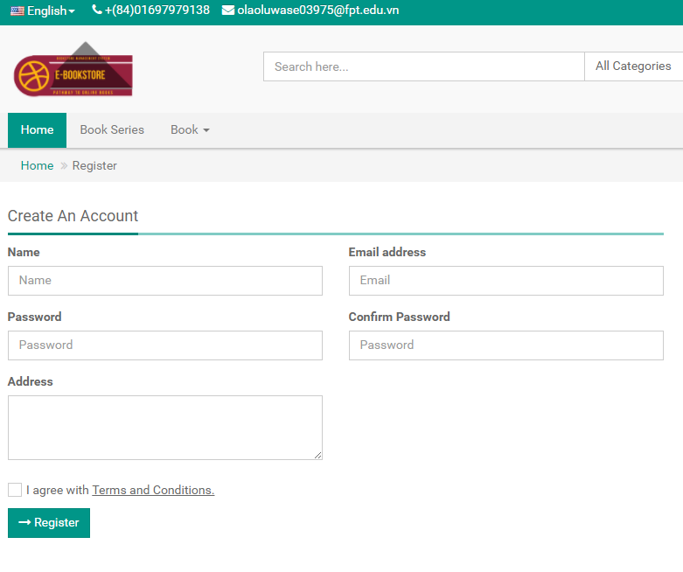

Figure 3.2.3

**Table 4-1:** Register Customer/Staff

|  |  |  |  |  |  |
| --- | --- | --- | --- | --- | --- |
| **No** | **Object/Control Name** | **Type** | **Required** | **Length** | **Description** |
| 1 | Name | Text-Field | Yes | 3-20 | Customer Name |
| 2 | Email | Email-Field | Yes | 7-30 | Customer Email Address |
| 3 | Password | Password-Field | Yes | > 6 | User password |
| 4 | Confirm Password | Password-Field | Yes | > 6 | Password verification |
| 5 | Address | MultiLine-Field | No | Max 50 | Customers Address |
| 6 | cbAccept | CheckBox | N/A | N/A | Check i agree with terms and condition to activate Register button |
| 7 | Register | Button | N/A | N/A | Registration button |

#### Sequence Diagram

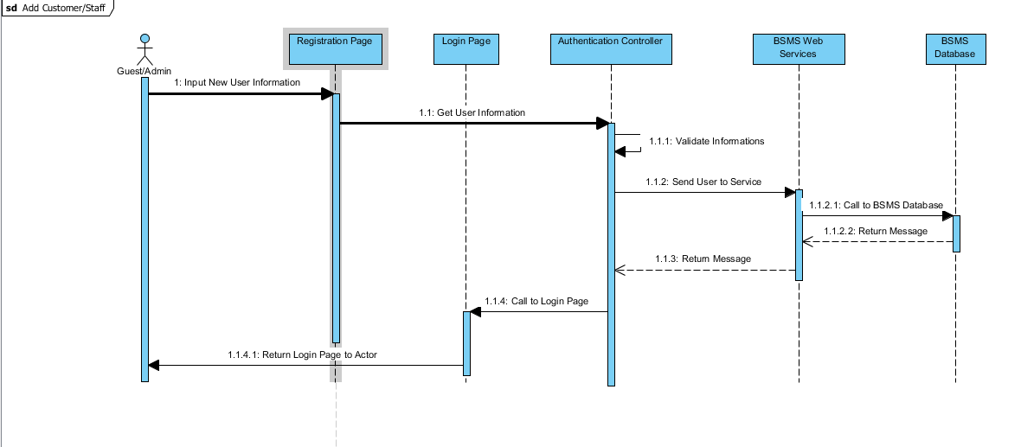

### Login

#### Description

Account holder of BSMS who might want to take action on the system, which might be required of him/her to login into the system, this applies to all stockholders of the system apart from the guest, logging in into the system will give the E-U some level of access to the system, assuming the scenario whereby a guest wish to save some book for feature reference, then he/she register an account as described in **3.2.3** after following a normal case, they login into the system to access the feature of wish list.

#### Screen Design

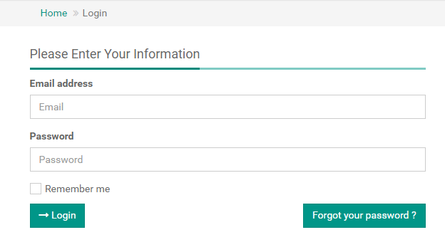

Figure 3.2.3

**Table 4-2:** Login

|  |  |  |  |  |  |
| --- | --- | --- | --- | --- | --- |
| **No** | **Object/Control Name** | **Type** | **Required** | **Length** | **Description** |
| 2 | Email | Email-Field | Yes | 7-30 | Customer Email Address |
| 3 | Password | Password-Field | Yes | > 6 | User password |
| 6 | cbRememberMe | CheckBox | N/A | N/A | Remember me, to keep user detail incase of next login |
| 7 | Login | Button | N/A | N/A | Login button |

#### Sequence Diagram

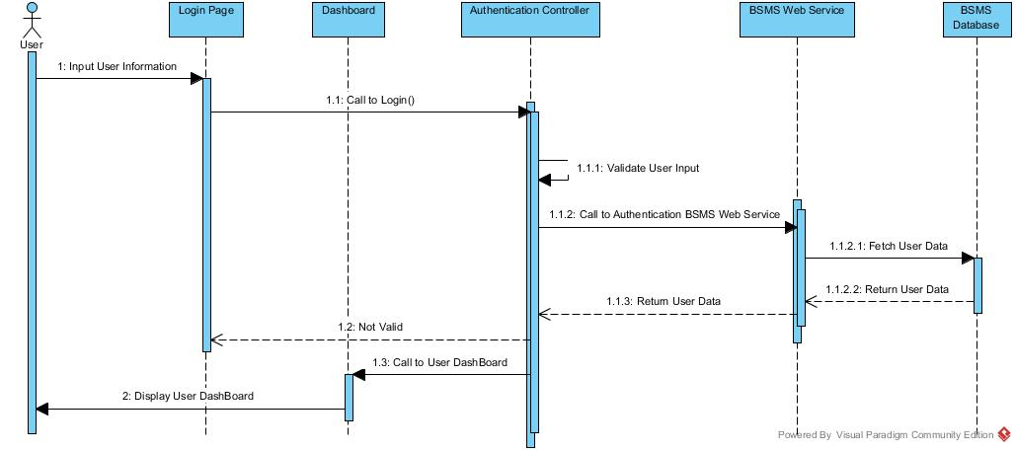

### Logout

#### Description

Logged user sometime might like to make use of the logout functionality, in order for guest users not to take advantage of their logged session, this feature will be most useful when the E-U uses another use PC/Desktop, in this case there is need to logout.

#### Screen Design

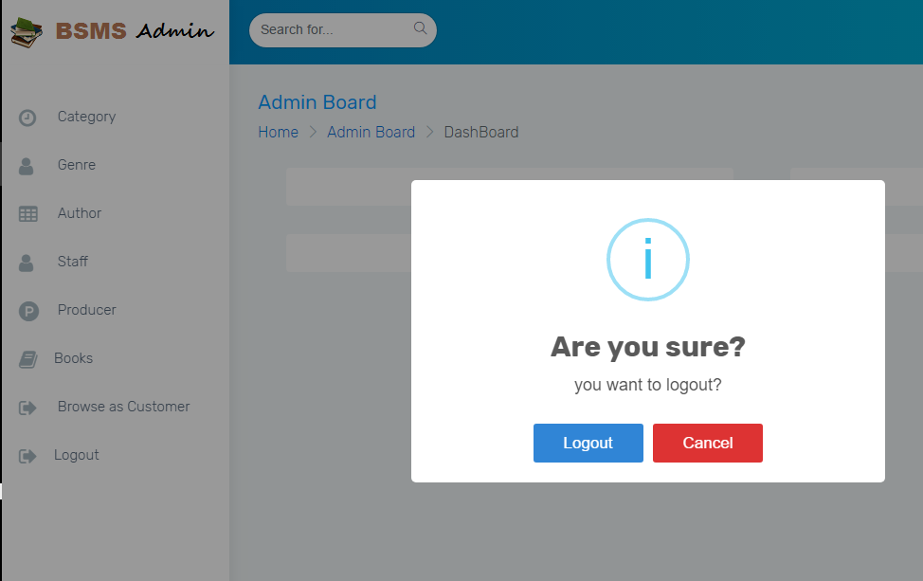

For Admin and Staff users

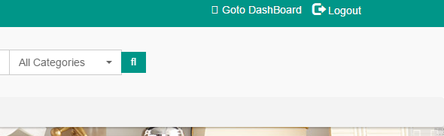

For customers

#### Sequence Diagram

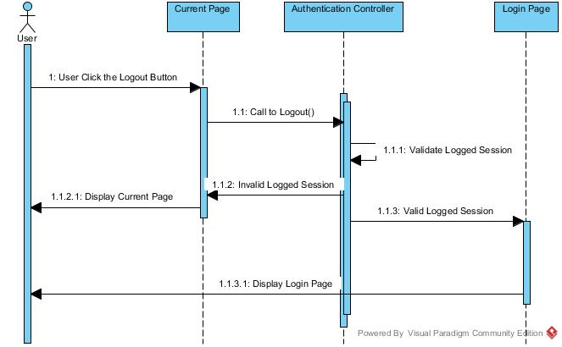

### Forget Password

#### Description

BSMS doesn’t expect her E-U to have the brain of computer, in case if any of her users forget their password, BSMS has provide a simple way to recover their password using the same email used while registering, in many case E-U might in one way or the other forget there password, using the forget password feature E-U is allow to reset there password using their email, as email is supposed to be a unique value.

#### Screen Design

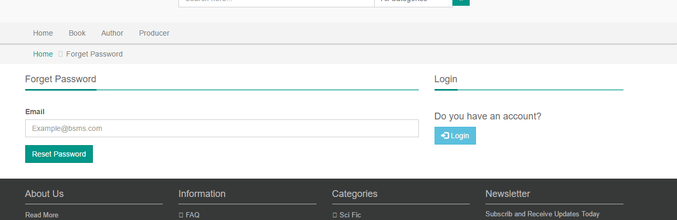

#### Sequence Diagram

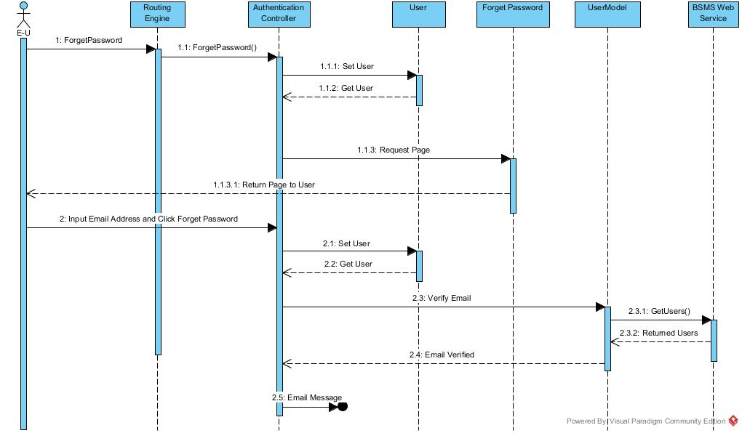

## Category Management

### Class Diagram

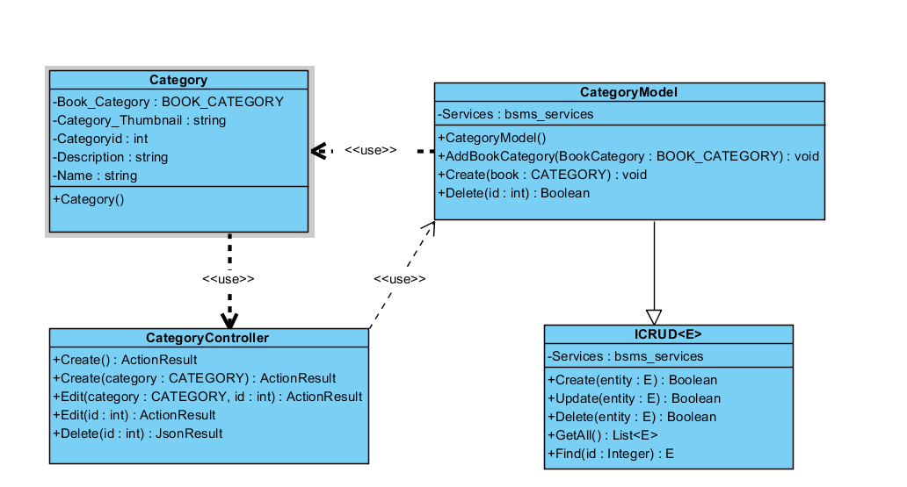

### Class Description

|  |  |  |
| --- | --- | --- |
| Class | Dependency | Description |
| Category | Role | The category class is a linq mapped entity class that holds all informations regarding category in BSMS. |
| ICRUD | N/A | This Interface is intended to create rules for all model class and sometimes the controller can also make use of this |
| CategoryModel | N/A | This class provide connection to BSMS SOAP services, CRUD operations will be handled by this model class |
| CategoryController | N/A | This controller class extends from the base class “Controller” which allow request to be mapped to it. |

#### Category

|  |  |  |  |
| --- | --- | --- | --- |
| Class | Category | | |
| **Description** | this class holds all category information including name, and description | | |
| **Base Class** | Object | | |
| **Constructor** | Default | | |
| **Prototype** |  | | |
| **Source File** | Category.cs | | |
| **Namespace** | BSMS.bsms.locahost | | |
| **Attributes** | Name | Type | Description |
| Name | String | N/A |
| Book\_Category | BOOK\_CATEGORY | N/A |
| Category\_Thumbnail | String | This field contains the image of a category |
| CategoryID | Int | This is a unique identifyer for each categories, and this is what serves as key BSMS uses in recorgnising a category |
| Description | String | This field contains description for category |

#### CategoryModel

|  |  |  |  |  |
| --- | --- | --- | --- | --- |
| Class | CategoryModel | | | |
| **Description** | This class provide connection to BSMS SOAP services, CRUD operations will be handled by this model class | | | |
| **Base Class** | Object | | | |
| **Constructor** | Default | | | |
| **Prototype** |  | | | |
| **Source File** | Category.cs | | | |
| **Namespace** | BSMS.Model | | | |
| **Attributes** | Name | Type | Description | |
| Services | Bsms\_services | A private instance of bsms soap web services | |
| **Methods** | Name | Input | Output | Description |
| AddBookCategory | BOOK\_CATEGORY | N/A | This method is use to add new book category into BSMS |
| Create | Category | void | This helper method is used to insert new category into the system |
|  | Delete | Int | Boolean | this is a static internal type of method, which allows existing category to be deleted as the name Delete implies |
|  | EditCategory | Category | Boolean | This model method edit information of category and return true if model state is valid, and false otherwise. |
|  | Fliter | Int | Category | This model method takes as input category id and return equivalent category as output if found, return null otherwise |

#### Category Controller

|  |  |  |  |  |
| --- | --- | --- | --- | --- |
| Class | CategoryController | | | |
| **Description** | This class provide connection to BSMS SOAP services, CRUD operations will be handled by this model class | | | |
| **Base Class** | System.web.controller | | | |
| **Constructor** | N/A | | | |
| **Prototype** |  | | | |
| **Source File** | CategoryController.cs | | | |
| **Namespace** | BSMS.Controller | | | |
| **Methods** | Name | Input | Output | Description |
| Create | N/A | ActionResult | This is serves as http get handler |
| Create | Category | ActionResult | This is a web method that handles user input for create |
|  | Edit | Int | ActionResult | This is a controller web method that handles all http get for Edit functionality |
| Edit | Category, int | ActionResult | This is a controller http post method that handles edit functionalities for categories |
| Index | N/A | ActionResult | http get method that handles list page |
| Delete | Int | JsonResult | http delete method that handles delete request from bsms |

### Add Category

In order to have category in our system, the admin might need to add one or more category so that we can categorize our books.

Adding Category in to the system is only allowed of the admin, which after the staff might add new book under the category.

#### Screen Design

#### Sequence Diagram

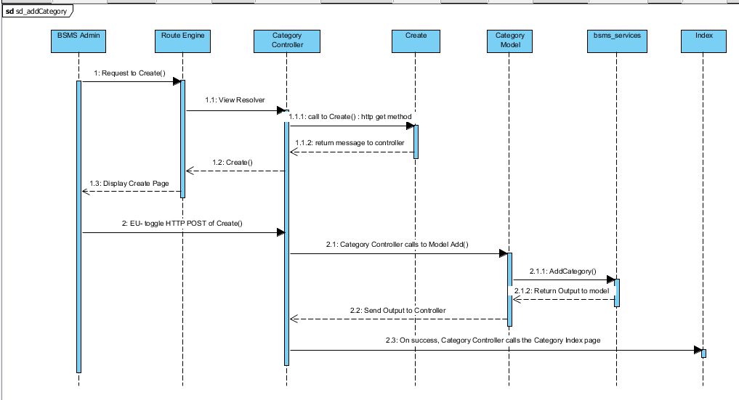

### Edit Category

This functionality allow previously created category to be edited if there exist any wrong information, editing information of category including the category name and other information e.g. changing category name from “Science Fiction” to “Sci Fi”

#### Screen Design

#### Sequence Diagram

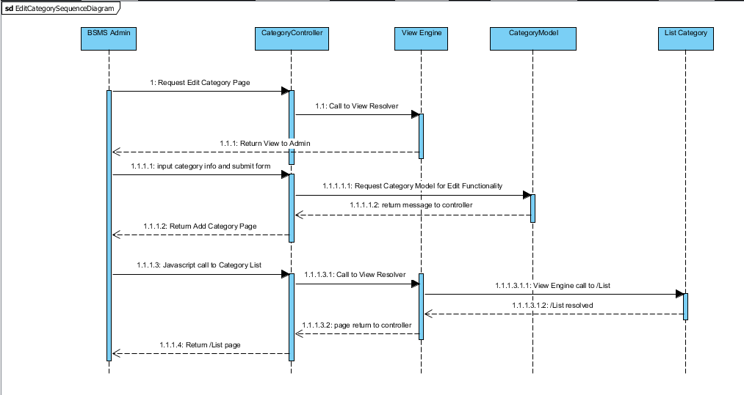

### List Category

The list category feature allow the admin use to view sequence categories that have been added into the system, with each element of the sequence having edit, delete and info icon. On click of each icon triggers equivalent event for each element in that list.

#### Screen Design

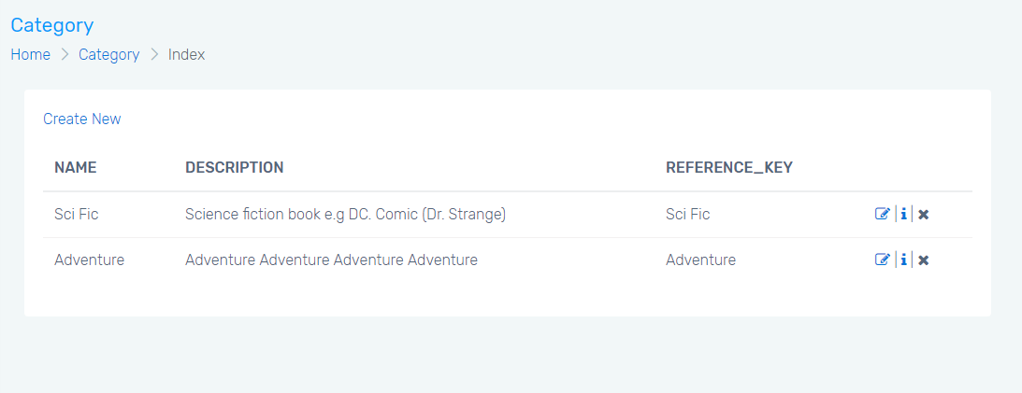

#### Sequence Diagram

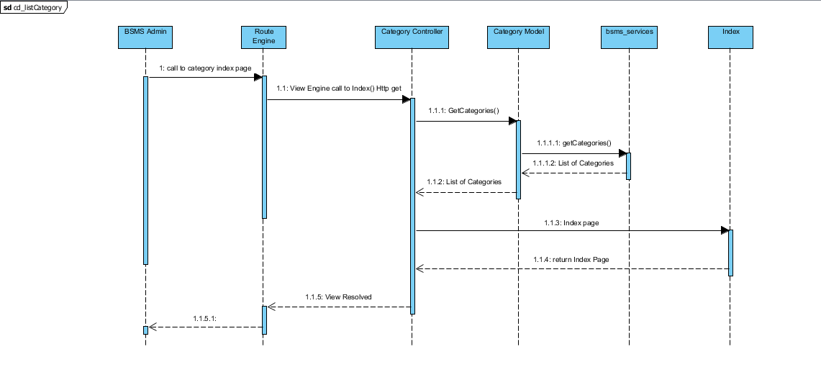

### Delete Category

This feature allow admin users to delete category from the system, this feature is useful in the case where admin user added wrong/duplicate/unnecessary category, this feature will allow admin to delete such category.

#### Screen Design

#### Sequence Diagram

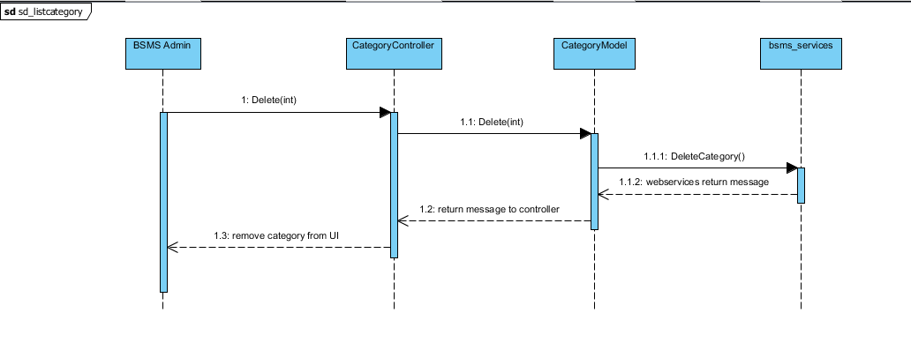

## Genre Management

### Class Diagram

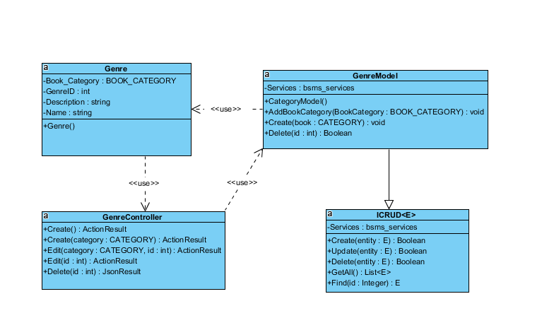

### Class Description

|  |  |  |
| --- | --- | --- |
| Class | Dependency | Description |
| Genre | N/A | The genre class is a linq mapped entity class that holds all information’s regarding genre in BSMS. |
| ICRUD | N/A | This Interface is intended to create rules for all model class and sometimes the controller can also make use of this |
| GenreModel | N/A | This class provide connection to BSMS SOAP services, CRUD operations will be handled by this model class |
| GenreController | N/A | This controller class extends from the base class “Controller” which allow request to be mapped to it. |

#### Genre

|  |  |  |  |
| --- | --- | --- | --- |
| Class | Genre | | |
| **Description** | this class holds all genre information including name, and description | | |
| **Base Class** | Object | | |
| **Constructor** | Default | | |
| **Prototype** |  | | |
| **Source File** | Genre.cs | | |
| **Namespace** | BSMS.bsms.localhost | | |
| **Attributes** | Name | Type | Description |
| Name | String | N/A |
| Book\_Genre | BOOK\_GENRE | N/A |
| GenreID | Int | This is a unique identifier for each genre’s, and this is what serves as key BSMS uses in recognising a Genre |
| Description | String | This field contains description for genre |

#### Genre Model

|  |  |  |  |  |
| --- | --- | --- | --- | --- |
| Class | GenreModel | | | |
| **Description** | This class provide connection to BSMS SOAP services, CRUD operations will be handled by this model class | | | |
| **Base Class** | Object | | | |
| **Constructor** | Default | | | |
| **Prototype** |  | | | |
| **Source File** | GenreModel.cs | | | |
| **Namespace** | BSMS.Model | | | |
| **Attributes** | Name | Type | Description | |
| Services | Bsms\_services | A private instance of bsms soap web services | |
| **Methods** | Name | Input | Output | Description |
| AddGenre | BOOK\_CATEGORY | N/A | This method is use to add new book category into BSMS |
| Create | Category | void | This helper method is used to insert new category into the system |
|  | Delete | Int | Boolean | this is a static internal type of method, which allows existing category to be deleted as the name Delete implies |

#### Genre Controller

|  |  |  |  |  |
| --- | --- | --- | --- | --- |
| Class | GenreController | | | |
| **Description** | This class provide connection to BSMS SOAP services, CRUD operations will be handled by this model class | | | |
| **Base Class** | System.web.controller | | | |
| **Constructor** | N/A | | | |
| **Prototype** |  | | | |
| **Source File** | GenreController.cs | | | |
| **Namespace** | BSMS.Controller | | | |
| **Methods** | Name | Input | Output | Description |
| Create | N/A | ActionResult | This is serves as http get handler |
| Create | Genre | ActionResult | This is a web method that handles user input for create |
|  | Edit | Int | ActionResult | This is a controller web method that handles all http get for Edit functionality |
| Edit | Genre, int | ActionResult | This is a controller http post method that handles edit functionalities for genres |
| Index | N/A | ActionResult | http get method that handles list page |
| Delete | Int | JsonResult | http delete method that handles delete request from bsms |

### Add Genre

In order to have genre in our system, the admin might need to add one or more genre so that we can differentiate the different type of book available in the system.

Adding genre in to the system is only allowed of the admin, which after the staff might add new book under the genre.

#### Screen Design

#### Sequence Diagram

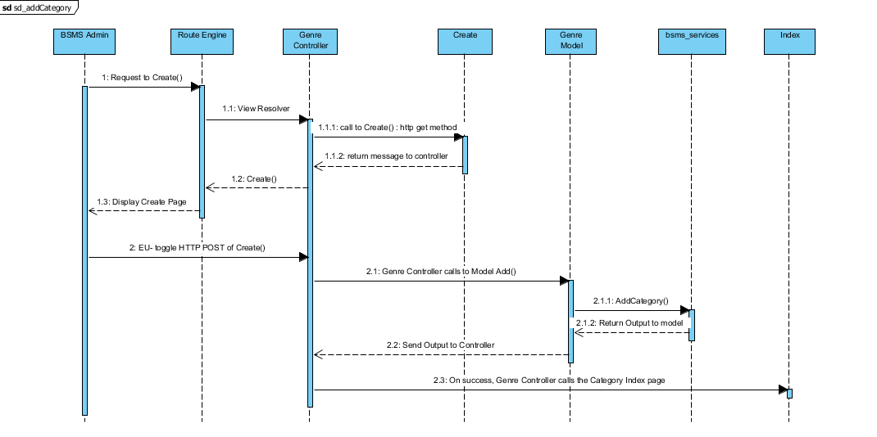

### Edit Genre

This functionality allow previously created genre to be edited if there exist any wrong information, editing information of genre including the genre name and other information e.g. changing genre name from “18+” to “Above 18”

#### Screen Design

#### Sequence Diagram

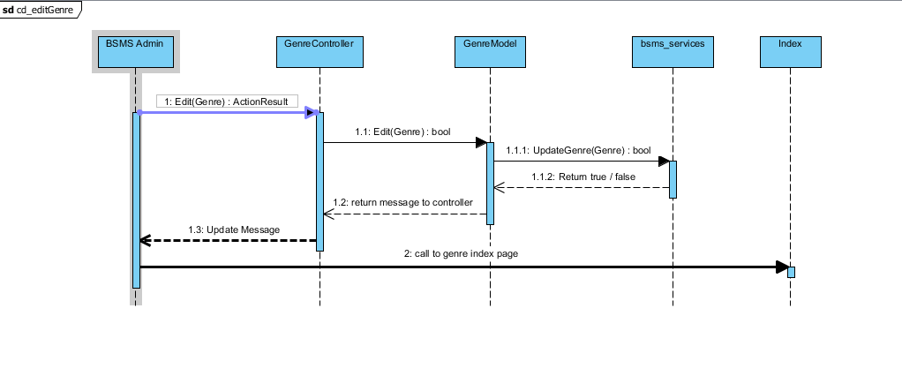

### List Genre

The list category feature allow the admin use to view sequence categories that have been added into the system, with each element of the sequence having edit, delete and info icon. On click of each icon triggers equivalent event for each element in that list.

#### Screen Design



#### Sequence Diagram

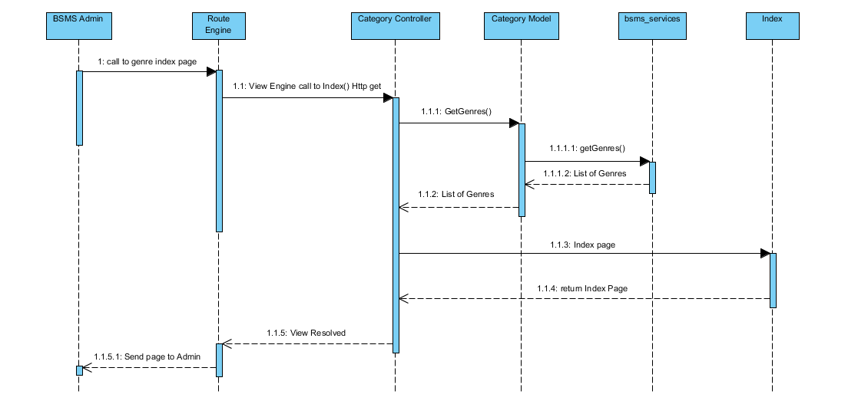

### Delete Genre

This feature allow admin users to delete category from the system, this feature is useful in the case where admin user added wrong/duplicate/unnecessary category, this feature will allow admin to delete such category.

#### Screen Design

#### Sequence Diagram

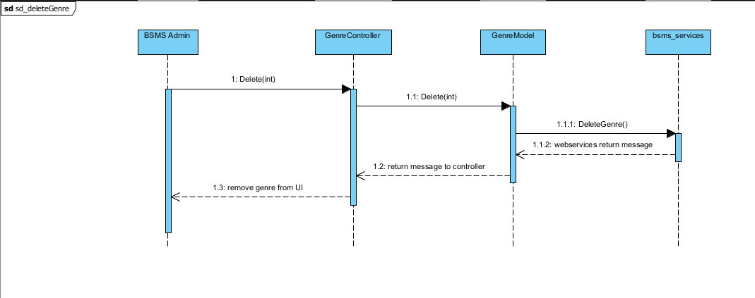

## Staff Management

### Class Diagram

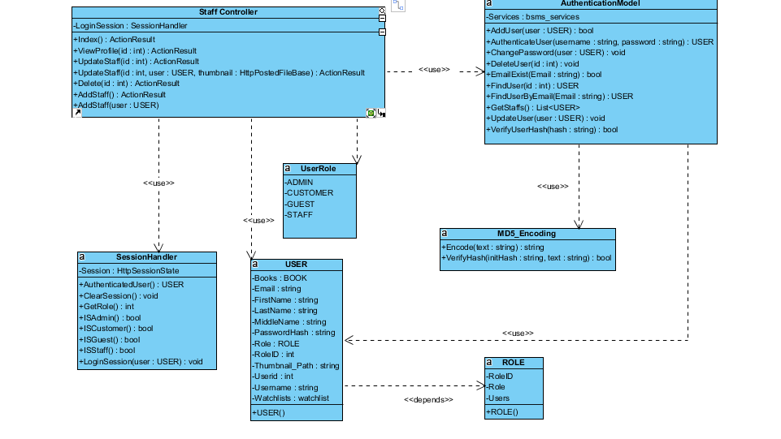

### Class Description

|  |  |  |
| --- | --- | --- |
| Class | Dependency | Description |
| User | Role | The user class holds all user data and information including all the usernames and passwords in the system, this is known as the BSMS user recognition methodology. |
| Role | N/A | This class is intended to hold unique set of roles for users, since the user uses this class as dependency, user has a role, which is how the system recognise the type of user coming into the system |
| AuthenticationController | N/A | This is a controller class that handles all operations that involving http Operations, once any corresponding http method is call the route engine fires up this controller by requesting it for action. |
| SessionHandler | N/A | This is an handler class that handles all session in the system, this class save and retrieves browsing session. |
| AuthenticationModel | USER | This is a class that handles all operations that involves Authentication including CRUD Operations, thus this class have direct connection to BSMS SOAP Webservices. |
| MD5\_Encoding | N/A | This class handles system encryption, Md5 password encoding and decoding |
| UserRole | N/A | This class contains user role dynamic attribute which save the id of each role. |

#### User

|  |  |  |  |  |
| --- | --- | --- | --- | --- |
| Class | User | | | |
| **Description** | User data, this class holds all the user information including the password and username | | | |
| **Base Class** | Object | | | |
| **Constructor** | Default | | | |
| **Prototype** |  | | | |
| **Source File** | User.cs | | | |
| **Namespace** | BSMS.Model | | | |
| **Attributes** | Name | Type | Description | |
| Name | String | N/A | |
| Username | String | Users username is contained in this attribute | |
| PasswordHash | String | This contains 64 digit MD5 encrypted password | |
| Email | String |  | |
| RoleID | int | This hold the role of user in number format ex. (1:”Staff” , 2:”Admin”) | |
|  | Thumbnail | String | This hold the thumbnail path in the system | |
| **Methods** | Name | Input | Output | Description |
| Authentication | Username  Password | User | This function check if user is valid or not, returns null if not valid and user information if valid |
| LoggedOn | N/A | Boolean | This function is intended to check if any user is logged on to the system |

#### Role

|  |  |  |  |
| --- | --- | --- | --- |
| Class | Role | | |
| **Description** | This contain all the user roles that exists in the system | | |
| **Base Class** | Object | | |
| **Constructor** | Default | | |
| **Prototype** |  | | |
| **Source File** | Role.cs | | |
| **Namespace** | BSMS.Model | | |
| **Attributes** | Name | Type | Description |
| Roleid | int | This is a unique integer value that holds a unique id for each role that exist in the system |
| Role | String | Role of this role e.g. (“Admin, Staff” .... ) |

#### Staff Controller

|  |  |  |  |  |
| --- | --- | --- | --- | --- |
| Class | StaffController | | | |
| **Description** | This class controls everything they deals with User and Roles | | | |
| **Base Class** | System.Web.Mvc.Controller | | | |
| **Constructor** | N/A | | | |
| **Prototype** |  | | | |
| **Source File** | AuthenticationController.cs | | | |
| **Namespace** | BSMS.Controller | | | |
| **Methods** | Name | Input | Output | Description |
| Index | N/A | ActionResult | This method make a request to the Http Get in order to request for a page |
| ViewProfile | int | ActionResult | This method call makes request to Http Post and calls the Authentication Model class to fetch user detail |
| UpdateStaff | N/A | ActionResult | On this method call E-U will be logged out of the system and redirect to the login page |
| UpdateStaff | N/A | ActionResult | Http Method call to request forget password page |
| Delete | String | ActionResult | Http Post method call to act on user input |
| AddStaff | N/A | ActionResult | Request made to register user or customer page |
| AddStaff | User | ActionResult | Process new user Http Post method |

#### Session Handler

|  |  |  |  |  |
| --- | --- | --- | --- | --- |
| Class | SessionHandler | | | |
| **Description** | This class acts as session assistant, in other words this class handles all session related activities | | | |
| **Base Class** | N/A | | | |
| **Constructor** | Default | | | |
| **Prototype** |  | | | |
| **Source File** | SessionHandler.cs | | | |
| **Namespace** | BSMS.Session | | | |
| **Attributes** | Name | Type | Description | |
| Session | HttpSessionState | The Session is an instance of the HttpSessionState, which contains the application context Session | |
| **Methods** | Name | Input | Output | Description |
|  | AuthenticatedUser | N/A | USER | This method return the currently logged in user, and returns it’s object |
| ClearSession | N/A | N/A | This method is used to clear application context session |
| GetRole | N/A | Integer | This method will be used to get role of currently loggeduser |
| ISAdmin | N/A | Boolean | This method is mean’t to check if currently logged in user is Admin |
| ISCustomer | N/A | Boolean | This method is mean’t to check if currently logged in user is Customer |
| ISGuest | N/A | Boolean | This method is mean’t to check if there is no logged user in the system |
| ISStaff | N/A | Boolean | This method is mean’t to check if currently logged in user is Staff |
| LoginSession | USER | N/A | This method is mainly used to create a login session, which mean this will be used only when users needs to login. |

#### Authentication Model

|  |  |  |  |  |
| --- | --- | --- | --- | --- |
| Class | AuthenticationModel | | | |
| **Description** | This is a class that handles all operations that involves Authentication including CRUD Operations, thus this class have direct connection to BSMS SOAP Webservices. | | | |
| **Base Class** | N/A | | | |
| **Constructor** | Default | | | |
| **Prototype** |  | | | |
| **Source File** | Authentication.cs | | | |
| **Namespace** | BSMS.Model | | | |
| **Attributes** | Name | Type | Description | |
| Services | bsms\_services | This is a private instance of “BSMS.SERVICES” | |
| **Methods** | Name | Input | Output | Description |
| AddUser | USER | Boolean | This method is use to call the webservices method inorder to add a new user into the system |
| AuthenticateUser | String, String | USER | This method is proposed to check if login credential is correct or not, this return null if username or password is incorrect and User Object otherwise |
| ChangePassword | USER | N/A | This method is used to change user passwords on reset password request |
| DeleteUser | Int | N/A | This static method is used to delete user from BSMS |
| FindUser | Int | USER | This static method return User Object which matches the id of user inpt |
| FindUserByEmail | Int | USER | This method is used to find user by email, since the email address of each user is unique |
| GetStaffs | N/A | List<USER> | This method is used to get all avaliable staff in the system |
| UpdateStaff | USER | N/A | This is used to update staff informations |
| VerifyUserHash | String | Boolean | This method is mainly used to verify hash code of users |

#### MD5\_Encoding

|  |  |  |  |  |
| --- | --- | --- | --- | --- |
| Class | MD5\_Encoding | | | |
| **Description** | This class handles encoding, like encode, decode | | | |
| **Base Class** | N/A | | | |
| **Constructor** | Default | | | |
| **Prototype** |  | | | |
| **Source File** | MD5\_Encoding.cs | | | |
| **Namespace** | BSMS.Model | | | |
| **Methods** | Name | Input | Output | Description |
| Encode | String | String | This function mainly encode input string to MD5 encryption |
| VerifyHash | String,String | Boolean | This function is intended to check if user password match its encypted format |

#### UserRole

|  |  |  |  |
| --- | --- | --- | --- |
| Class | UserRole | | |
| **Description** | This class acts like enum class, as this keeps static variables of each types of users that exist in the system | | |
| **Base Class** | Object | | |
| **Constructor** | Default | | |
| **Prototype** |  | | |
| **Source File** | UserRole.cs | | |
| **Namespace** | BSMS.Model | | |
| **Attribute** | Name | Type | Description |
| ADMIN | int | This contains role id of Admin users |
| CUSTOMER | int | This contains role id of Customer users |
|  | GUEST | int | This contains role id of Guest users |
|  | STAFF | int | This contains role id of Staff users |

### Add Staff

Adding staff in to the system is one of the many functionality that is only allowed of the admin user, which after the staff will be given some level of access to the system and allowed to perform some operations.

#### Screen Design

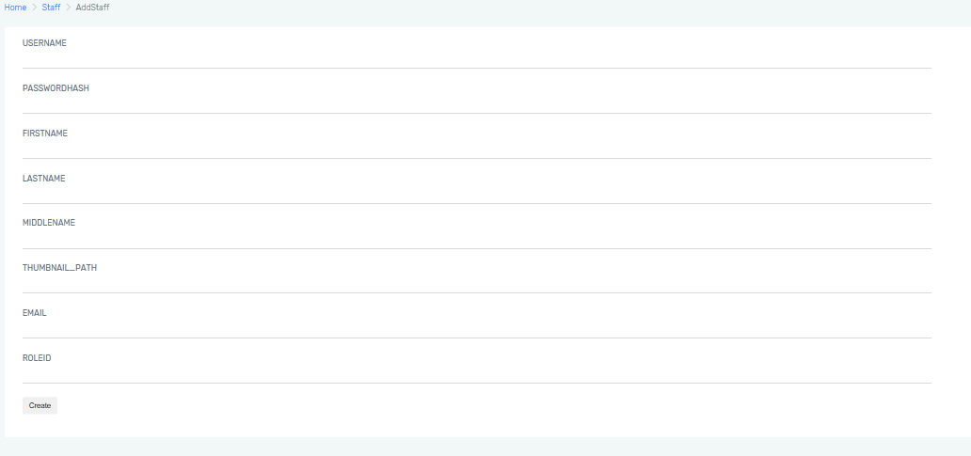

#### Sequence Diagram

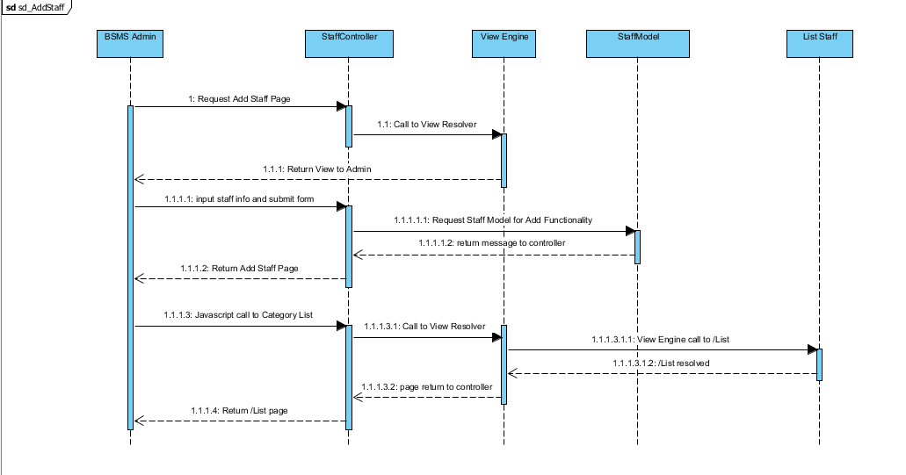

### Edit Staff

This functionality allow previously created staff to be edited if there exist any wrong information, editing information of staff including the name and other information e.g. changing staff first name from “Joe” to “John”

#### Screen Design

#### Sequence Diagram

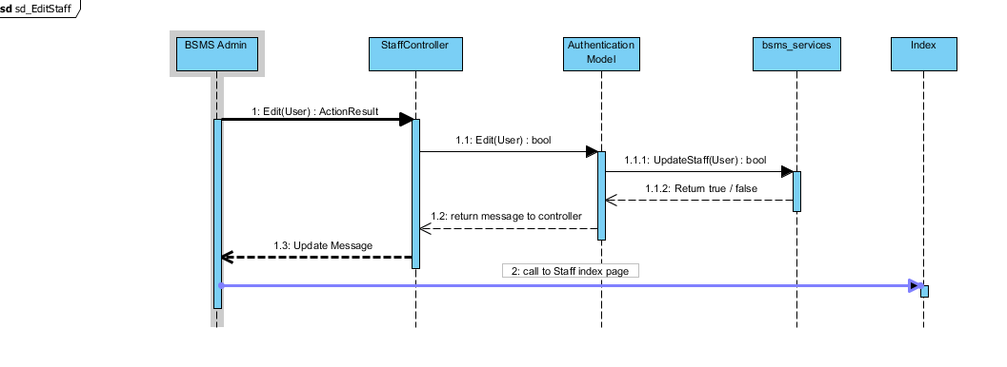

### List Staff

The list staff feature allow the admin use to view sequence staffs that have been added into the system, with each element of the sequence having edit, delete and info icon. On click of each icon triggers equivalent event for each element in that list.

#### Screen Design

#### Sequence Diagram

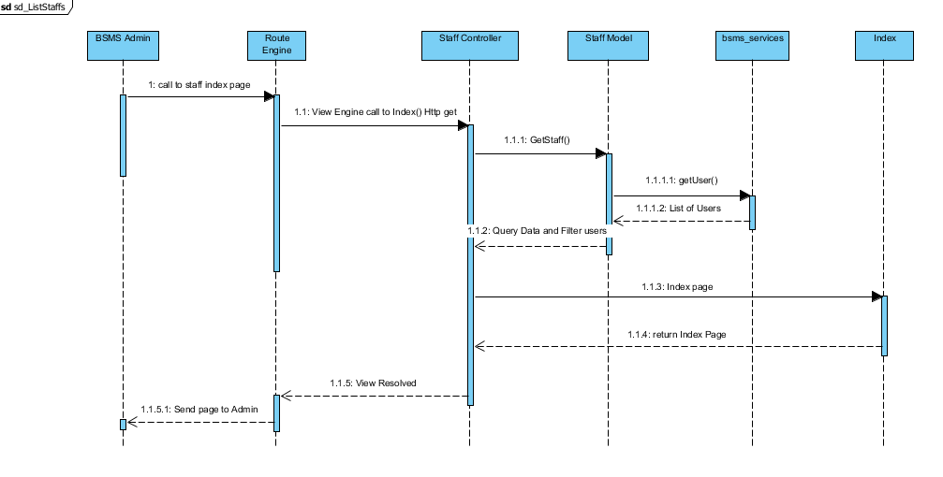

### Delete Staff

This feature is only allowed of the admin users to delete staffs from the system, this feature is useful in the case where admin user added wrong/duplicate/unnecessary category, and this feature will allow admin to remit such mistake.

#### Screen Design

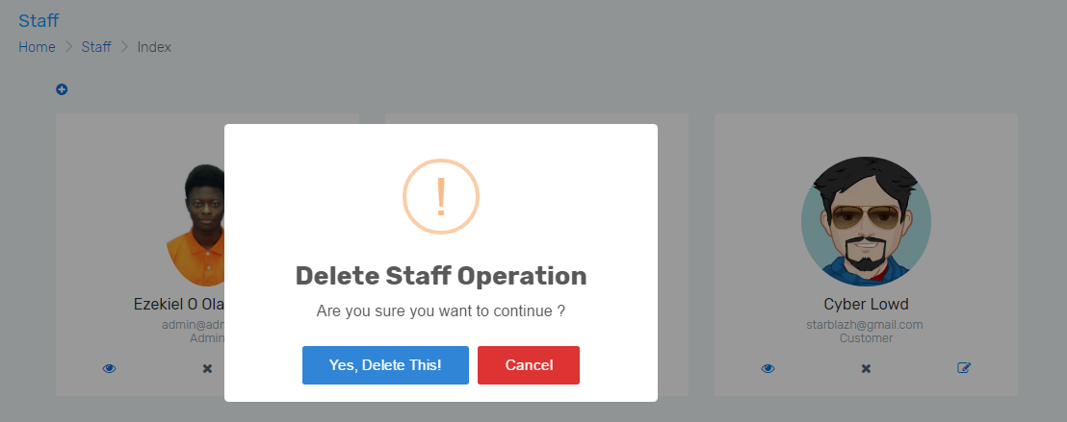

#### Sequence Diagram

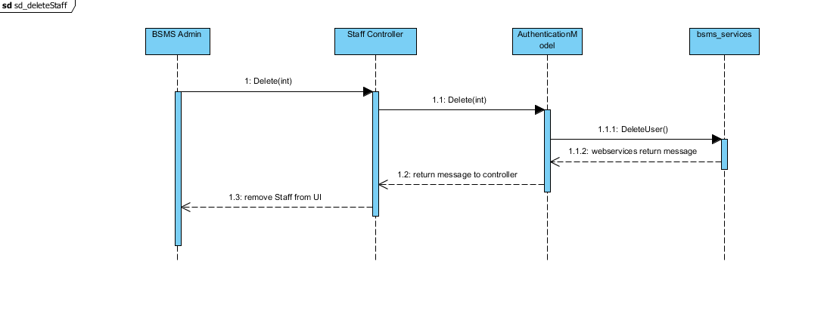

## Book Management

### Class Diagram

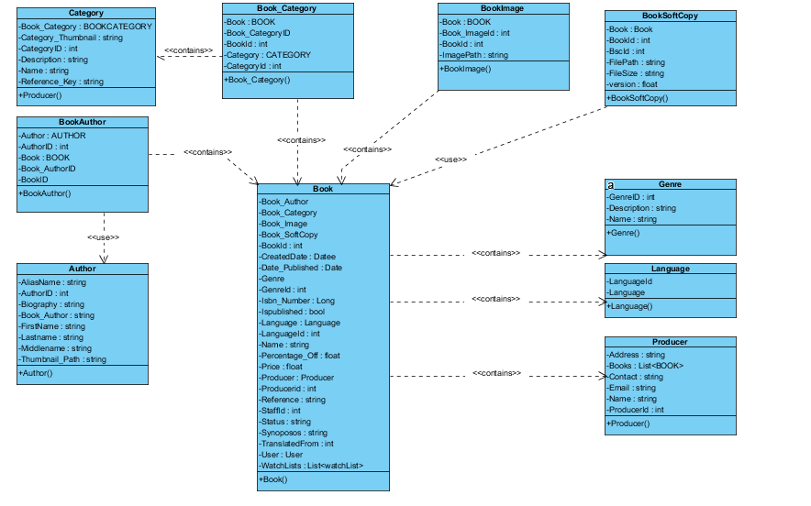

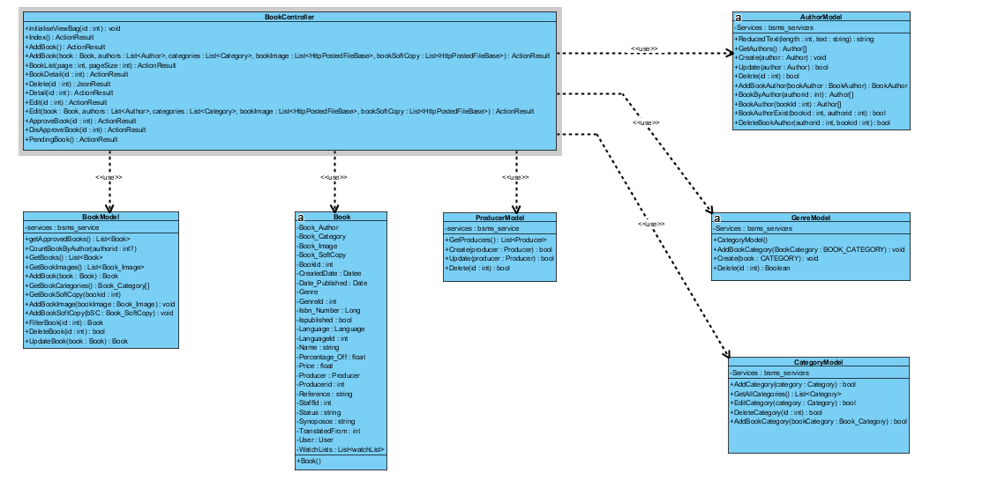

### Class Description

|  |  |  |
| --- | --- | --- |
| Class | Dependency | Description |
| BookAuthor | N/A | Book author is a linq database mapped entity class, that store the information of Book and that of its Author |
| BookCategory | N/A | Book Category is a linq database mapped entity class, that store the information of Book and that of its Category |
| BookImage | N/A | Book image is a linq database mapped entity class, that store the information of Book and that of its image |
| BookSoftCopy | N/A | Book soft copy is a linq database mapped entity class, that store the information of Book and that of its soft copy, normally .pdf formatted file. |
| Author |  | Author is a linq database mapped entity class, which store the information of Author. |
| Category |  | Category is a linq database mapped entity class, which store the information of category. |
| Producer |  | Producer is a linq database mapped entity class, which store the information of producer. |
| Language |  | Language is a linq database mapped entity class, which store the information of language. |
| Genre |  | Genre is a linq database mapped entity class, which store the information of genre. |
| AuthorModel |  | This is a class that handles all operations that involves Author including CRUD Operations, thus this class have direct connection to BSMS SOAP Webservices. |
| CategoryModel |  | This is a class that handles all operations that involves Category including CRUD Operations, thus this class have direct connection to BSMS SOAP Webservices. |
| BookModel |  | This is a class that handles all operations that involves book including CRUD Operations, thus this class have direct connection to BSMS SOAP Webservices. |
| ProducerModel |  | This is a class that handles all operations that involves Producer including CRUD Operations, thus this class have direct connection to BSMS SOAP Webservices. |
| GenreModel |  | This is a class that handles all operations that involves Genre including CRUD Operations, thus this class have direct connection to BSMS SOAP Webservices. |
| BookController |  | This is a class that handles all operations that involves book including CRUD Operations, thus this class have direct connection to BSMS SOAP Webservices. |
| Book |  |  |

#### BookAuthor

|  |  |  |  |
| --- | --- | --- | --- |
| Class | BookAuthor | | |
| **Description** | This is an entity class that holds all information with regards to Book Author, information including book, and author information. | | |
| **Base Class** | Object | | |
| **Constructor** | Default | | |
| **Prototype** |  | | |
| **Source File** | BookAuthor.cs | | |
| **Namespace** | BSMS.bsms.localhost | | |
| **Attributes** | Name | Type | Description |
| Author | Author | N/A |
| AuthorId | Int | N/A |
| Book | Book | This is a unique identifyer for each geries, and this is what serves as key BSMS uses in recorgnising a Genre |
| BookAuthorId | Int | This field contains description for genre |
| BookId | Int |  |

#### BookCategory

|  |  |  |  |
| --- | --- | --- | --- |
| Class | BookCategory | | |
| **Description** | This is an entity class that holds information of category and books, Mapped linq to sql entity class. | | |
| **Base Class** | Object | | |
| **Constructor** | Default | | |
| **Prototype** |  | | |
| **Source File** | BookCategory.cs | | |
| **Namespace** | Object | | |
| **Attribute** | Name | Type | Description |
| book | Book | This method is use to add new book category into BSMS |
| bookId | int | This helper method is used to insert new category into the system |
| categoryId | int | this is a static internal type of method, which allows existing category to be deleted as the name Delete implies |
| category | Category | 44 |
| book\_categoryId | int |  |

#### BookImage

|  |  |  |  |
| --- | --- | --- | --- |
| Class | BookImage | | |
| **Description** | This class provide connection to BSMS SOAP services, CRUD operations will be handled by this model class | | |
| **Base Class** | Object | | |
| **Constructor** | N/A | | |
| **Prototype** |  | | |
| **Source File** | BookImage.cs | | |
| **Namespace** | BSMS.bsms.localhost | | |
| **Methods** | Name | Type | Description |
| book | Book | This is serves as http get handler |
| book\_imageId | int | This is a web method that handles user input for create |
|  | bookid | Int | This is a controller web method that handles all http get for Edit functionality |
| imagePath | string | This is a controller http post method that handles edit functionalities for genres |

#### BookSoftCopy

|  |  |  |  |
| --- | --- | --- | --- |
| Class | BookSoftCopy | | |
| **Description** | This class provide connection to BSMS SOAP services, CRUD operations will be handled by this model class | | |
| **Base Class** | Object | | |
| **Constructor** | N/A | | |
| **Prototype** |  | | |
| **Source File** | BookSoftCopy.cs | | |
| **Namespace** | BSMS.bsms.localhost | | |
| **Methods** | Name | Type | Description |
| book | Book | This is serves as http get handler |
| bookId | int | This is a web method that handles user input for create |
|  | bscId | Int | This is a controller web method that handles all http get for Edit functionality |
| filePath | string | This is a controller http post method that handles edit functionalities for genres |
|  | fileSize | int |  |
|  | version | float |  |

#### Author

|  |  |  |  |
| --- | --- | --- | --- |
| Class | Author | | |
| **Description** | This class provide connection to BSMS SOAP services, CRUD operations will be handled by this model class | | |
| **Base Class** | Object | | |
| **Constructor** | N/A | | |
| **Prototype** |  | | |
| **Source File** | Author.cs | | |
| **Namespace** | BSMS.bsms.localhost | | |
| **`** | Name | Type | Description |
| aliasName | Book | Author’s alias name |
| authorId | Int | Author’s unique identifier |
|  | biography | Int | Biography of author, this might contains the background history of this author. |
| Book\_author | String | This is a controller http post method that handles edit functionalities for genres |
|  | firstName | String | Author first name |
|  | lastName | String | Author last name |
|  | middleName | String | Author’s Middle name |

#### Category

|  |  |  |  |
| --- | --- | --- | --- |
| Class | Category | | |
| **Description** | This class provide connection to BSMS SOAP services, CRUD operations will be handled by this model class | | |
| **Base Class** | Object | | |
| **Constructor** | Default | | |
| **Prototype** |  | | |
| **Source File** | Category.cs | | |
| **Namespace** | BSMS.bsms.localhost | | |
| **Attributes** | Name | Type | Description |
| book\_category | BookCategory | This is serves as http get handler |
| category\_thumbnail | String | This is a web method that handles user input for create |
|  | categoryid | Int | This is a controller web method that handles all http get for Edit functionality |
| description | string | This is a controller http post method that handles edit functionalities for genres |
|  | name | String |  |
|  | reference\_key | String |  |

#### Producer

|  |  |  |  |
| --- | --- | --- | --- |
| Class | Producer | | |
| **Description** | This class provide connection to BSMS SOAP services, CRUD operations will be handled by this model class | | |
| **Base Class** | Object | | |
| **Constructor** | Default | | |
| **Prototype** |  | | |
| **Source File** | Producer.cs | | |
| **Namespace** | BSMS.bsms.localhost | | |
| **Attributes** | Name | Type | Description |
| address | BookCategory | This is serves as http get handler |
| books | List<Book> | This is a web method that handles user input for create |
|  | email | String | This is a controller web method that handles all http get for Edit functionality |
| name | String | This is a controller http post method that handles edit functionalities for genres |
|  | producerid | Int |  |

#### Language

|  |  |  |  |
| --- | --- | --- | --- |
| Class | Category | | |
| **Description** | This class provide connection to BSMS SOAP services, CRUD operations will be handled by this model class | | |
| **Base Class** | Object | | |
| **Constructor** | Default | | |
| **Prototype** |  | | |
| **Source File** | Category.cs | | |
| **Namespace** | BSMS.bsms.localhost | | |
| **Attributes** | Name | Type | Description |
| books | List<Book> | This is serves as http get handler |
| Language | String | This is a web method that handles user input for create |
|  | languageid | Int | This is a controller web method that handles all http get for Edit functionality |

#### Genre

|  |  |  |  |
| --- | --- | --- | --- |
| Class | Genre | | |
| **Description** | this class holds all genre information including name, and description | | |
| **Base Class** | Object | | |
| **Constructor** | Default | | |
| **Prototype** |  | | |
| **Source File** | Genre.cs | | |
| **Namespace** | BSMS.bsms.localhost | | |
| **Attributes** | Name | Type | Description |
| Name | String | N/A |
| Book\_Genre | BOOK\_GENRE | N/A |
| GenreID | Int | This is a unique identifyer for each geries, and this is what serves as key BSMS uses in recorgnising a Genre |
| Description | String | This field contains description for genre |
|  |  |  |

#### AuthorModel

|  |  |  |  |  |
| --- | --- | --- | --- | --- |
| Class | AuthorModel | | | |
| **Description** | This class provide connection to BSMS SOAP services, CRUD operations will be handled by this model class | | | |
| **Base Class** | Object | | | |
| **Constructor** | Default | | | |
| **Prototype** |  | | | |
| **Source File** | AuthorModel.cs | | | |
| **Namespace** | BSMS.Model | | | |
| **Attributes** | Name | Type | Description | |
| localhost | Bsms\_services | A private instance of bsms soap web services | |
| **Methods** | Name | Input | Output | Description |
| ReducedText | Int , String | String | This method reduces string values to the number of length passed as parameter to it |
| GetAuthors | N/A | List<Author> | This helper method is used to get all record of author from the soap web services |
|  | Create | Author | Boolean | This helper method is used when creating a new author, which incase if parameter passed is valid then it performs the add functionality on bsms dastabase and returns true and false otherwise |
|  | Update | Author | Boolean | This helper method is used when updating an existing author, which incase if parameter passed is valid then it performs update functionality on bsms dastabase and returns true and false otherwise |
|  | Delete | Int | Boolean | this is a static internal type of method, which allows existing category to be deleted as the name Delete implies |
|  | AddBookAuthor | Book\_Author | Boolean | This helper method is used when creating a new book author, which incase if parameter passed is valid then it performs the add functionality on bsms dastabase and returns true and false otherwise |
|  | BookByAuthor | Int | List<Book> | This Author model static method takes as input, id of author and returns back to invoking class list of book written by the author, if author id is incorrect they system returns and empty list. |
|  | BookAuthor | Int | List<Author> | The static method takes as input id of book and returns back to the invoking parent a sequence of author which is the author that wrote the book |
|  | BookAuthorExist | Int, Int | Boolean | The main intention of creating this method in author is to verify if book author have previously exist in the system. This method takes in book id and author id and check if they exist or not, as the name implies. |
|  | DeleteBookAuthor | Int, Int | Boolean | This method carries out the delete operation for Book Author as a result of invoking this method, book author information that match the invoked parameters will be permanently delete from bsms. |

#### CategoryModel

|  |  |  |  |  |
| --- | --- | --- | --- | --- |
| Class | CategoryModel | | | |
| **Description** | This class provide connection to BSMS SOAP services, CRUD operations will be handled by this model class | | | |
| **Base Class** | Object | | | |
| **Constructor** | Default | | | |
| **Prototype** |  | | | |
| **Source File** | Category.cs | | | |
| **Namespace** | BSMS.Model | | | |
| **Attributes** | Name | Type | Description | |
| Services | Bsms\_services | A private instance of bsms soap web services | |
| **Methods** | Name | Input | Output | Description |
| AddBookCategory | BOOK\_CATEGORY | N/A | This method is use to add new book category into BSMS |
| Create | Category | void | This helper method is used to insert new category into the system |
|  | Delete | Int | Boolean | this is a static internal type of method, whcih allows existing category to be deleted as the name Delete implies |
|  | EditCategory | Category | Boolean | This model method edit information of category and return true if model state is valid, and false otherwise. |
|  | Fliter | Int | Category | This model method takes as input category id and return equivalent category as output if found, return null otherwise |

#### BookModel

|  |  |  |  |  |
| --- | --- | --- | --- | --- |
| Class | bookModel | | | |
| **Description** | This class provide connection to BSMS SOAP services, CRUD operations will be handled by this model class | | | |
| **Base Class** | Object | | | |
| **Constructor** | Default | | | |
| **Prototype** |  | | | |
| **Source File** | BookModel.cs | | | |
| **Namespace** | BSMS.Model | | | |
| **Attributes** | Name | Type | Description | |
| service | Bsms\_services | A private instance of bsms soap web services | |
| **Methods** | Name | Input | Output | Description |
| GetApprovedBooks | N/A | List<Book> | This method query data from web services and return all books that have been approved |
| CountBookByAuthor | Int | Int | This helper method is used to get the amount of book that have been written by a particular author. |
|  | GetBooks | N/A | List<Book> | This model method main function is to get all books from the web service without filter |
|  | AddBook | Book | Boolean | Model method that performs add functionality into the system, by call the add book web method as describe in the web method description below |
|  | GetBookCategories | N/A | List<BookCategory> | This is a static internal type of method, which get all book categories from the web services without any filter added. |
|  | GetBookSoftCopy | N/A | List<Book\_SoftCopy> | This is a static internal type of method, which get all book book soft copy from the web services without any filter added. |
|  | AddBookImage | Book\_Image | Boolean | This Book model static method takes as input, the book image object and returns back to invoking parent Boolean result, if book image is successfully added in the system returns true and false otherwise. |
|  | AddBookSoftCopy | Book\_SoftCopy | Boolean | This Book model static method takes as input, the book soft copy object and returns back to invoking parent Boolean result, if object is successfully added in the system returns true and false otherwise. |
|  | FilterBook | Int | Book | The aim of this model method is to search for a particular book in the system, and returns book that match the given id, null otherwise |
|  | DeleteBook | Int | Boolean | This method carries out the delete operation for Book as a result of invoking this method, book information that match the invoked parameters will be permanently delete from bsms. |
|  | UpdateBook | Book | Boolean | This method carries out the update operation on book. As a result of invoking this method, book information that match the invoked parameters will be permanently updated and changes committed to bsms database. |

#### ProducerModel

|  |  |  |  |  |
| --- | --- | --- | --- | --- |
| Class | ProducerModel | | | |
| **Description** | This class provide connection to BSMS SOAP services, CRUD operations will be handled by this model class | | | |
| **Base Class** | Object | | | |
| **Constructor** | Default | | | |
| **Prototype** |  | | | |
| **Source File** | Producer.Model.cs | | | |
| **Namespace** | BSMS.Model | | | |
| **Attributes** | Name | Type | Description | |
| Services | Bsms\_services | A private instance of bsms soap web services | |
| **Methods** | Name | Input | Output | Description |
| GetProducer | N/A | List<Producer> | This model helper method communicates directly with the bsms web service to fetch data from the database |
| Create | Producer | void | This helper method is used to insert new producer into the system |
|  | Delete | Int | Boolean | this is a static internal type of method, which allows existing producer to be deleted as the name Delete implies. |
|  | Update | Producer | Boolean | This is a static internal method that performs edit operation for producers by calling its equivalent web method in the web service, this returns Boolean result as output. |
|  | Filter | Int | Producer | This method main intention is to find and return producer that match the given unique value, this method will return null is not match is found. |

#### Genre Model

|  |  |  |  |  |
| --- | --- | --- | --- | --- |
| Class | GenreModel | | | |
| **Description** | This class provide connection to BSMS SOAP services, CRUD operations will be handled by this model class | | | |
| **Base Class** | Object | | | |
| **Constructor** | Default | | | |
| **Prototype** |  | | | |
| **Source File** | GenreModel.cs | | | |
| **Namespace** | BSMS.Model | | | |
| **Attributes** | Name | Type | Description | |
| Services | Bsms\_services | A private instance of bsms soap web services | |
| **Methods** | Name | Input | Output | Description |
| GetGenre | Genre | N/A | This method is use to add new book genre into BSMS |
| Create | Genre | void | This helper method is used to insert new genre into the system |
|  | Delete | Int | Boolean | this is a static internal type of method, which allows existing category to be deleted as the name Delete implies |

#### BookController

|  |  |  |  |  |
| --- | --- | --- | --- | --- |
| Class | BookController | | | |
| **Description** | This class controls everything they deals with User and Roles | | | |
| **Base Class** | System.Web.Mvc.Controller | | | |
| **Constructor** | N/A | | | |
| **Prototype** |  | | | |
| **Source File** | BookController.cs | | | |
| **Namespace** | BSMS.Controller | | | |
| **Methods** | Name | Input | Output | Description |
| initialiseViewBag | Int | N/A | This is a privater controller method that initialise all view bags values for the view to make use of. |
| Index | N/A | ActionResult | This is the http get method, which return the list of all book as action result to the view to make use of. |
| AddBook | N/A | ActionResult | Http get method to display the add book page. |
| AddBook | Book, List<Author>, List<int>, List<HttpPostFileBase>, List<HttpPostFileBase> | ActionResult | Http Post method of book controller that handles add request by calling the static method add of BookModel class. |
| BookList | N/A | ActionResult | This book list method show list of books for the guest and customer users which display all the list of approved books |
| BookDetail | Int | ActionResult | Http get request method handler that process and display information of book with the given id. |
| Delete | Int | JsonResult | http delete method that handles delete request from bsms |
|  | BookDetail | Int | ActionResult | Http get request method handler that process and display information of book with the given id for admin users. |
|  | Edit | Int | ActionResult | Http get method to display the edit book page o any book that match the given id, if such book is does not exist this will return Http Not found with status code 404. |
|  | Edit | Book, List<Author>, List<int>, List<HttpPostFileBase>, List<HttpPostFileBase> | ActionResult | Http Post method of book controller that handles edit request by calling the static method update of BookModel class. |
|  | ApprovedBook | Int | JsonResult | Http post method that handles the approve functionality of bsms, at the call of this controller method, book will be immediately approve |
|  | DisApprovedBook | Int | JsonResult | Http post method that handles the disapprove functionality of bsms, at the call of this controller method, book will be immediately disapprove |
|  | PendingBooks | N/A | ActionResult | This http post method of book controller main intention is to display list of pending book |

#### Book

|  |  |  |  |
| --- | --- | --- | --- |
| Class | Book | | |
| **Description** | this class holds all book information including name, and synopsis | | |
| **Base Class** | Object | | |
| **Constructor** | Default | | |
| **Prototype** |  | | |
| **Source File** | Book.cs | | |
| **Namespace** | BSMS.bsms.localhost | | |
| **Attributes** | Name | Type | Description |
| Book\_Author | Book\_Author | Book author information |
| Book\_Category | Book\_Category | Book category information |
| Book\_Image | Book\_Image | Book image information |
| BookId | Int | This field contain the unique identifier for each book |
| CreatedDate | Date | Book created date time stamp |
|  | Date\_Published | Date | Book date publish time stamp |
|  | Genre | Genre | Book genre information |
|  | Genreid | Int | Book genre unique id |
|  | Isbn\_number | BigInt | Book isbn number |
|  | IsPublished | Boolean | Boolean value to confirm if book is published or not. |
|  | Language | Language | Book language object that stores the language the book is written in. |
|  | LanguageId | Int | Book language id |
|  | Name | String | Name of the book |
|  | Percentage\_Off | Float | Percentage off from the book |
|  | Price | Float | Unit / Original price of the book |
|  | Producer | Producer | Book producer information |
|  | ProducerId | Int | Book producer id |
|  | Reference | String | Web link that contains reference to the given book |
|  | StaffId | Int | Book staff id |
|  | Status | String | Book status “Approve” or “Not Approve” |
|  | Synopsis | String | Book synopsis information |
|  | TranslatedFrom | Int | Book translated from |
|  | User | User | This field store the id of the staff whom add this book into bsms |
|  | WatchLists | List<WatchList> | List of wishlist |

### Add Book

Adding book is one of the most important feature of our system and in order for bsms to work correctly there is need for adding a book. Adding a book requires so many dependencies

#### Screen Design

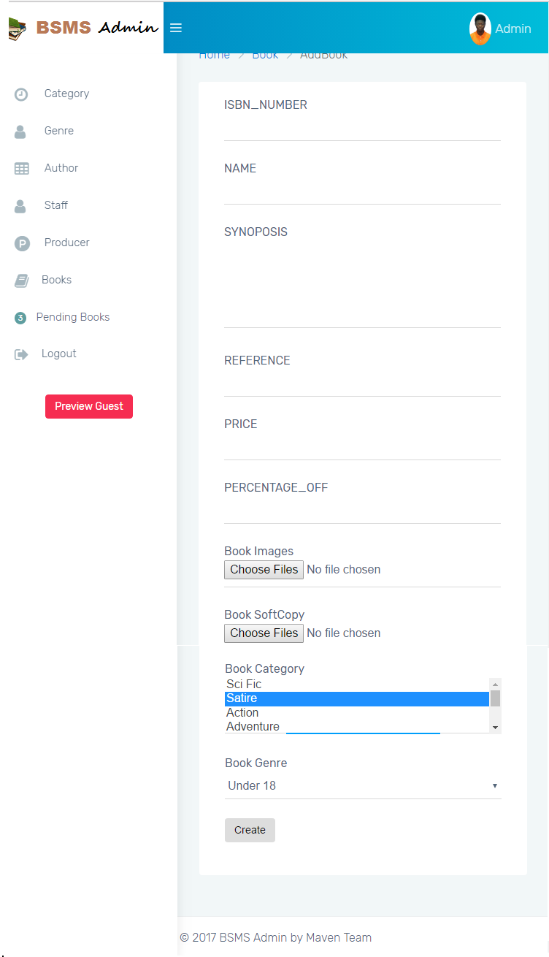

#### Sequence Diagram

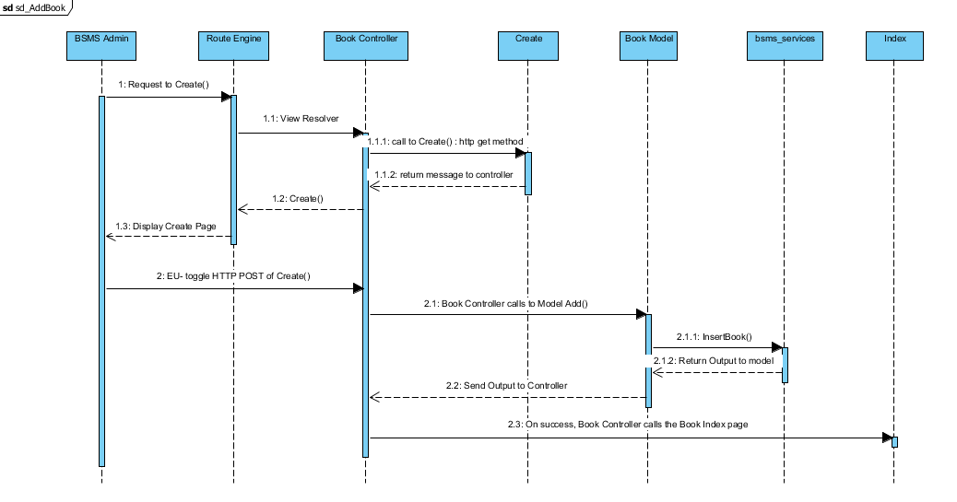

### Book Detail

This functionality allow previously created books to view and all details about the book revealed to the E-U including Authors information, Producer, Genre and many other info.

#### Sequence Diagram

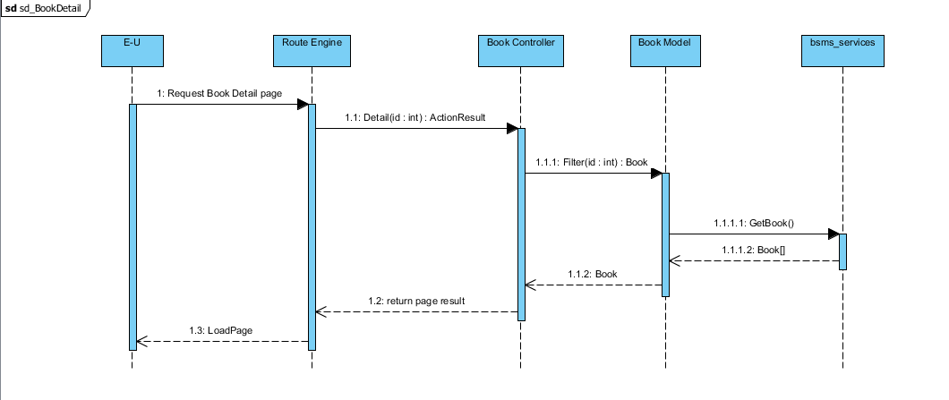

### Edit Book

The edit book functionality allow the staff users to view and update book information, from this same page you can choose to delete book image, book author and other book dependency information

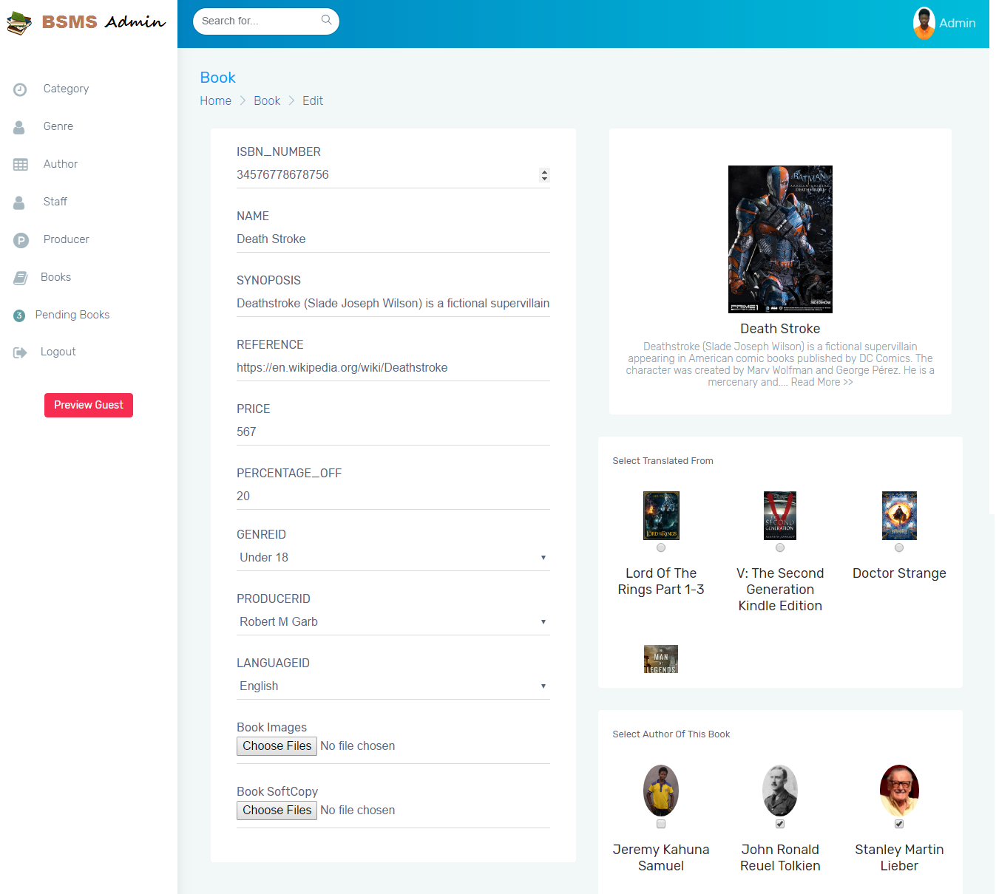

#### Screen Design

#### Sequence Diagram

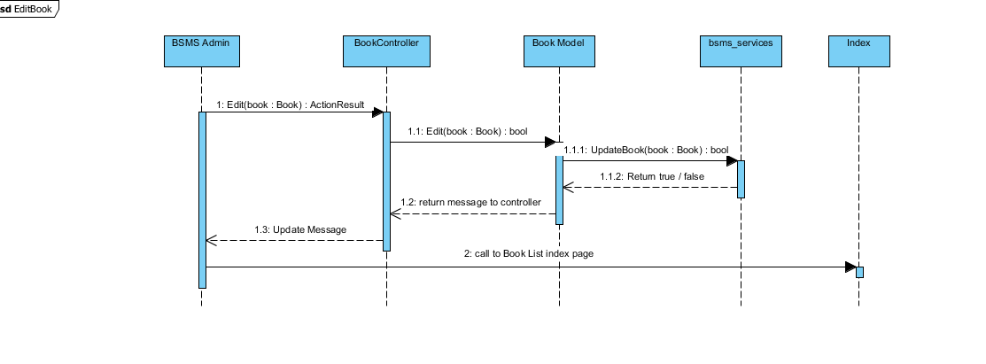

### Delete Book

This feature allow staff users to delete book from the system, this feature is useful in the case where a staff user added wrong/duplicate/ unnecessary book, this feature will allow admin to delete such book.

#### Screen Design

#### Sequence Diagram

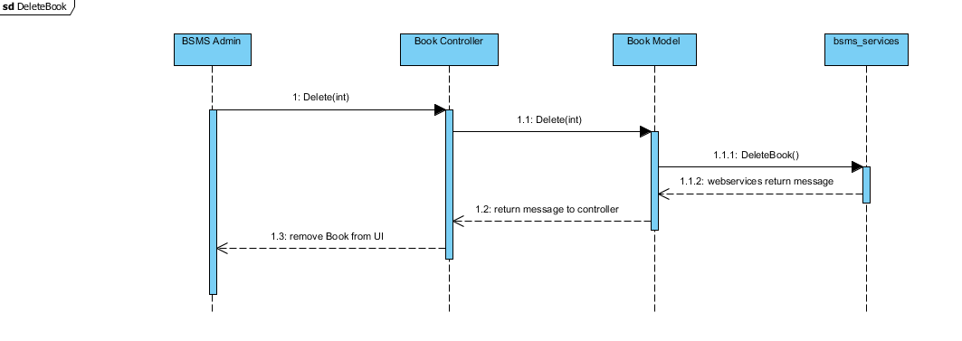

### Approve/Disapprove Book

In order to allow customers and guest to see newly added book there is neeed to approve such book, this functionality is only allowed of the admin, which he/she need to review new books and decide whether the book is allowed or not.

#### Screen Design

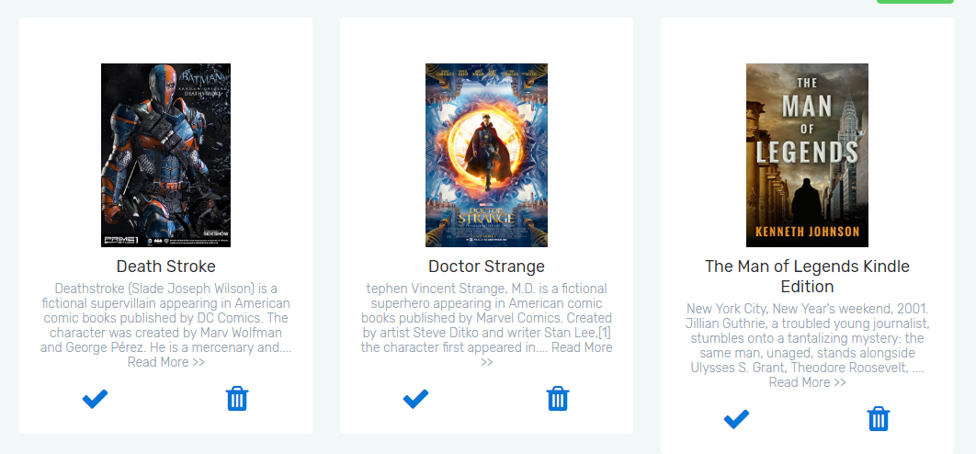

#### Sequence Diagram

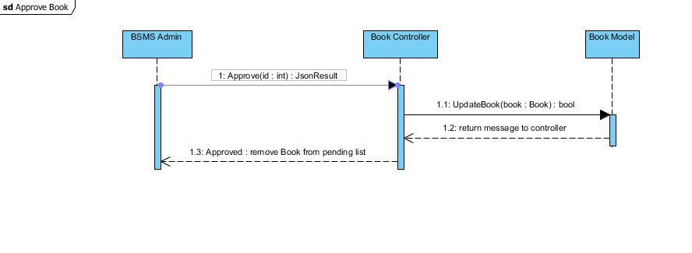

## Wishlist Management

### Class Diagram

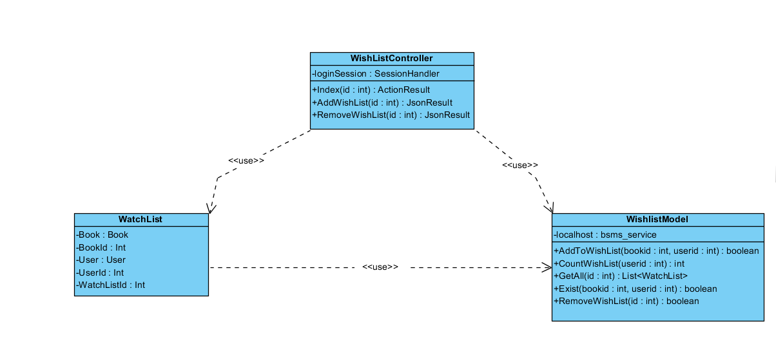

### Class Description

|  |  |  |
| --- | --- | --- |
| Class | Dependency | Description |
| WatchList | Role | The watchlist class holds all user data and information including all the book and user, linq to sql mapped entity class. |
| WishlistModel | N/A | This model class is intended to perform CRUD operations and some other simple operation for the wishlist including add, remove, count and get functionality. |
| WishListController | N/A | This is a controller class that handles all operations that involving http Operations, once any corresponding http method is call the route engine fires up this controller by requesting it for action. |

#### WatchList

|  |  |  |  |
| --- | --- | --- | --- |
| Class | WatchList | | |
| **Description** | The watchlist class holds all user data and information including all the book and user, linq to sql mapped entity class. | | |
| **Base Class** | Object | | |
| **Constructor** | Default | | |
| **Prototype** |  | | |
| **Source File** | User.cs | | |
| **Namespace** | BSMS.Model | | |
| **Attributes** | Name | Type | Description |
| Book | Book | N/A |
| Bookid | int | Users username is contained in this attribute |
| User | User | This contains 64 digit MD5 encrypted password |
| Userid | int |  |
| wishlistid | int | This hold the role of user in number format ex. (1:”Staff” , 2:”Admin”) |
| Thumbnail | String | This hold the thumbnail path in the system |

#### WishlistModel

|  |  |  |  |  |
| --- | --- | --- | --- | --- |
| Class | WishlistModel | | | |
| **Description** | This model class is intended to perform CRUD operations and some other simple operation for the wishlist including add, remove, count and get functionality. | | | |
| **Base Class** | N/A | | | |
| **Constructor** | Default | | | |
| **Prototype** |  | | | |
| **Source File** | Role.cs | | | |
| **Namespace** | BSMS.Model | | | |
| **Attributes** | Name | Type | Description | |
| localhost | bsms\_service | Localhost is an instance of the soap web service that manages all the action wishlist model takes. | |
| **Methods** | Name | Input | Output | Description |
|  | AddToWishList | WatchList | Boolean | This model method takes as input the watchlist object and output Boolean result, true if wishlist addition is successful and false otherwise |
| CountWishList | Int | Int | This model method query data to count the amount of watchlist a particular user have. |
| GetAll | Int | List<WatchList> | Model method that return all the watchlist a particular user have in the database |
| Exist | Int, Int | Boolean | Model method that check if the specify user and book id already exist in the database, this method helps in eliminating duplicate values. |
| RemoveWishList | Int | Boolean | This model method takes as input the watchlist id and output Boolean result, true if wishlist have been successfully removed and false otherwise |

#### WishListController

|  |  |  |  |  |
| --- | --- | --- | --- | --- |
| Class | WishListController | | | |
| **Description** | This controller class handles all http method request, and serves as page backend controller. | | | |
| **Base Class** | System.Web.Mvc.Controller | | | |
| **Constructor** | N/A | | | |
| **Prototype** |  | | | |
| **Source File** | WishListController.cs | | | |
| **Namespace** | BSMS.Controller | | | |
| **Methods** | Name | Input | Output | Description |
| Index | Int | ActionResult | This method make a request to the Http Get in order to request for a wishlist a currently logged user |
| AddWishList | int | JsonResult | This method call makes request to Http Post and calls the Wishlist Model class to add a new wishlist. |
| RemoveWishList | N/A | ActionResult | This method call makes request to Http Post and calls the Wishlist Model class to remove an existing wishlist. |

### Add To WishList

Adding wishlist operation in to the system is one of the many functionality that is only allowed of the customer user, which after they can view in the wishlist page and they can view and delete the book from their wishlist page if they so desired.

#### Screen Design

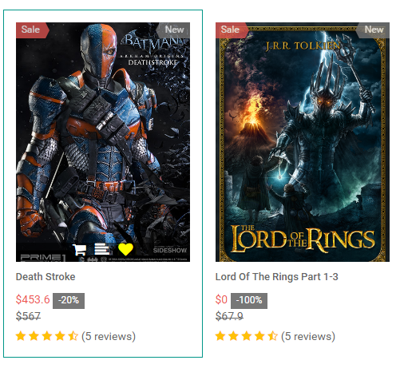

#### Sequence Diagram

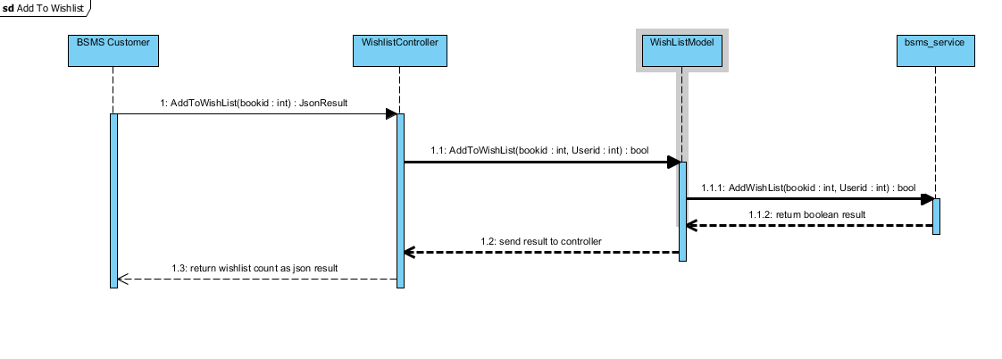

### Remove WishList

This functionality allow previously created wishlist to be delete if customer desires to remove this from his wishlist page.

#### Screen Design

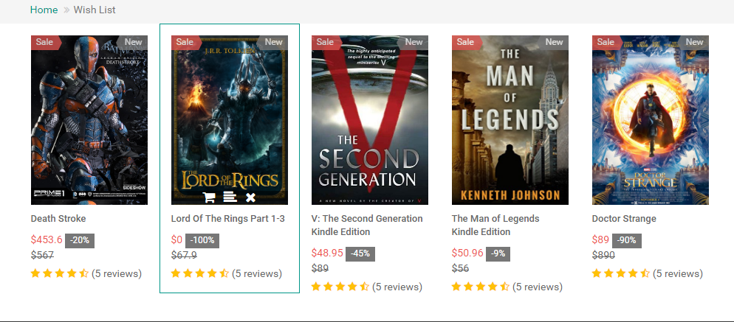

#### Sequence Diagram

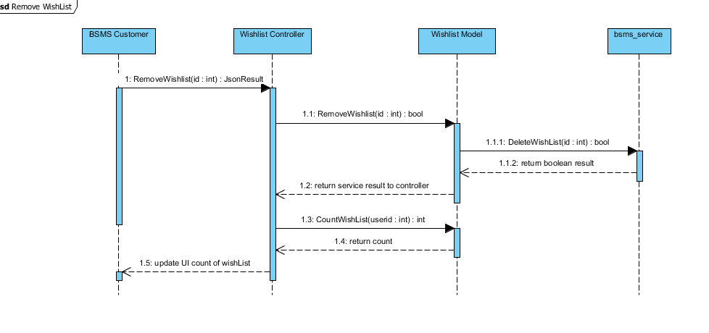

## Author Management

### Class Diagram

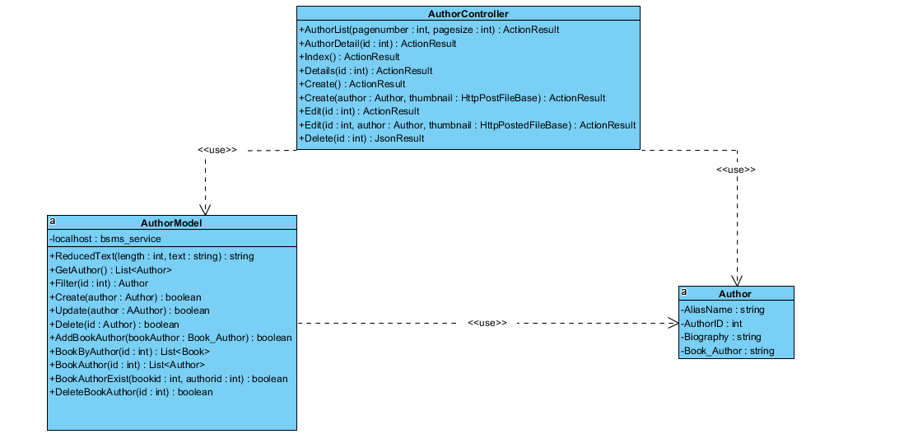

### Class Description

|  |  |  |
| --- | --- | --- |
| Class | Dependency | Description |
| Author | Role | The user class holds all user data and information including all the usernames and passwords in the system, this is known as the BSMS user recognition methodology. |
| AuthorModel | N/A | This class is intended to hold unique set of roles for users, since the user uses this class as dependency, user has a role, which is how the system recognise the type of user coming into the system |
| AuthorController | N/A | This is a controller class that handles all operations that involving http Operations, once any corresponding http method is call the route engine fires up this controller by requesting it for action. |

#### Author

|  |  |  |  |
| --- | --- | --- | --- |
| Class | Author | | |
| **Description** | This class provide connection to BSMS SOAP services, CRUD operations will be handled by this model class | | |
| **Base Class** | Object | | |
| **Constructor** | N/A | | |
| **Prototype** |  | | |
| **Source File** | Author.cs | | |
| **Namespace** | BSMS.bsms.localhost | | |
| **`** | Name | Type | Description |
| aliasName | Book | Author’s alias name |
| authorId | Int | Author’s unique identifier |
|  | biography | Int | Biography of author, this might contains the background history of this author. |
| Book\_author | String | This is a controller http post method that handles edit functionalities for genres |
|  | firstName | String | Author first name |
|  | lastName | String | Author last name |
|  | middleName | String | Author’s Middle name |
|  | Thumbnail\_path | String | Author image path in the web server |

#### AuthorModel

|  |  |  |  |  |
| --- | --- | --- | --- | --- |
| Class | AuthorModel | | | |
| **Description** | This class provide connection to BSMS SOAP services, CRUD operations will be handled by this model class | | | |
| **Base Class** | Object | | | |
| **Constructor** | Default | | | |
| **Prototype** |  | | | |
| **Source File** | AuthorModel.cs | | | |
| **Namespace** | BSMS.Model | | | |
| **Attributes** | Name | Type | Description | |
| localhost | Bsms\_services | A private instance of bsms soap web services | |
| **Methods** | Name | Input | Output | Description |
| ReducedText | Int , String | String | This method reduces string values to the number of length passed as parameter to it |
| GetAuthors | N/A | List<Author> | This helper method is used to get all record of author from the soap web services |
|  | Create | Author | Boolean | This helper method is used when creating a new author, which incase if parameter passed is valid then it performs the add functionality on bsms dastabase and returns true and false otherwise |
|  | Update | Author | Boolean | This helper method is used when updating an existing author, which incase if parameter passed is valid then it performs update functionality on bsms dastabase and returns true and false otherwise |
|  | Delete | Int | Boolean | this is a static internal type of method, which allows existing category to be deleted as the name Delete implies |
|  | AddBookAuthor | Book\_Author | Boolean | This helper method is used when creating a new book author, which incase if parameter passed is valid then it performs the add functionality on bsms dastabase and returns true and false otherwise |
|  | BookByAuthor | Int | List<Book> | This Author model static method takes as input, id of author and returns back to invoking class list of book written by the author, if author id is incorrect they system returns and empty list. |
|  | BookAuthor | Int | List<Author> | The static method takes as input id of book and returns back to the invoking parent a sequence of author which is the author that wrote the book |
|  | BookAuthorExist | Int, Int | Boolean | The main intention of creating this method in author is to verify if book author have previously exist in the system. This method takes in book id and author id and check if they exist or not, as the name implies. |
|  | DeleteBookAuthor | Int, Int | Boolean | This method carries out the delete operation for Book Author as a result of invoking this method, book author information that match the invoked parameters will be permanently delete from bsms. |

#### Author Controller

|  |  |  |  |  |
| --- | --- | --- | --- | --- |
| Class | AuthorController | | | |
| **Description** | This class controls everything they deals with Author, http hander class for author. | | | |
| **Base Class** | System.Web.Mvc.Controller | | | |
| **Constructor** | N/A | | | |
| **Prototype** |  | | | |
| **Source File** | AuthorController.cs | | | |
| **Namespace** | BSMS.Controller | | | |
| **Methods** | Name | Input | Output | Description |
| AuthorList | Int , Int | ActionResult | This method make a request to the Http Get in order to request for a page |
| AuthorDetail | int | ActionResult | This method call makes request to Http get and calls then Author Model class to fetch author’s detail |
| Index | N/A | ActionResult | On call of this http get method, will in turn return the list author page in the admin and staff dashboard |
| Details | Int | ActionResult | Http Method call to view detail of author |
| Create | N/A | ActionResult | Http get method to display the create page of author. |
| Create | Author, HttppostFileBase | ActionResult | This is an http post request method which save a new author in to the database |
| Edit | Int | ActionResult | This is an http get method to display the edit author page that match the given id |
|  | Edit | Int,Author, HttppostFileBase | ActionResult | This is an http post request method which make changes to the database |
|  | Delete | Int | JsonResult | This is an http post request method which at call of it return Json result back to invoking client and also delete Author information from the database if there exist such user. |

### Add Author

Adding author in to the system is one of the many functionality that is only allowed of the staff user, which after adding a valid author information, the staff can then can book information.

#### Screen Design

#### Sequence Diagram

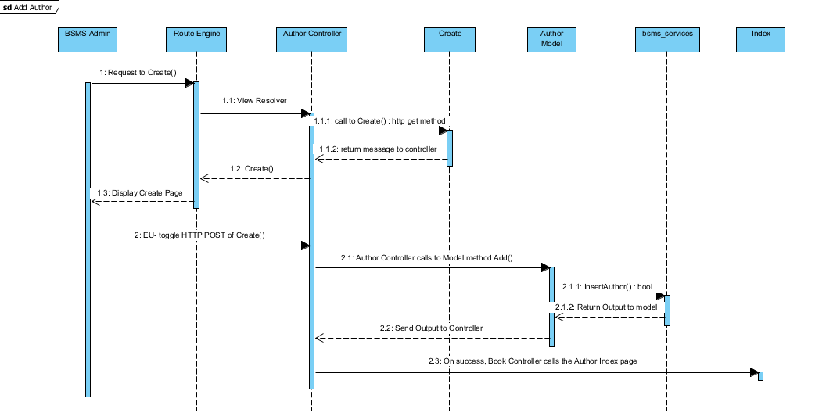

### Edit Author

This functionality allow previously created author to be edited if there exist any wrong information, editing information of author including the name and other information e.g. changing author first name from “Joe” to “John”

#### Screen Design

#### Sequence Diagram

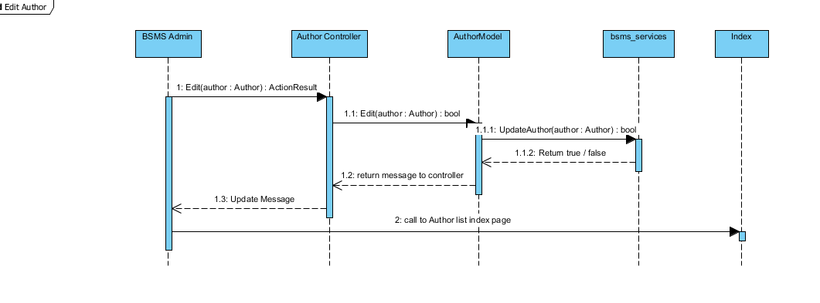

### List Author

The list author feature allow the admin and staff to view sequence authors that have been added into the system, with each element of the sequence having edit, delete and info icon. On click of each icon triggers equivalent event for each element in that list.

#### Screen Design

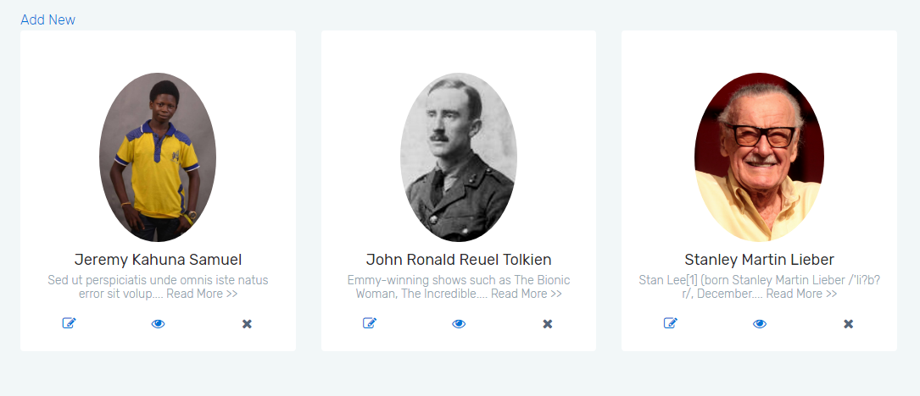

#### Sequence Diagram

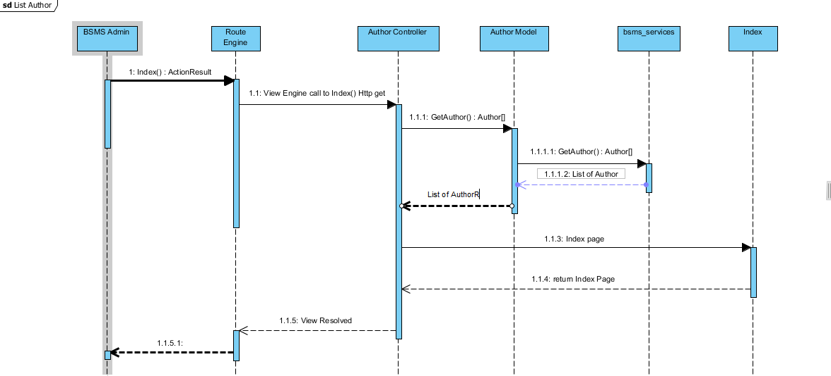

### Delete Author

This feature is only allowed of the staff users to delete author from the system, this feature is useful in the case where staff user added wrong/duplicate/unnecessary category, and this feature will allow admin to remit such mistake.

#### Screen Design

#### Sequence Diagram

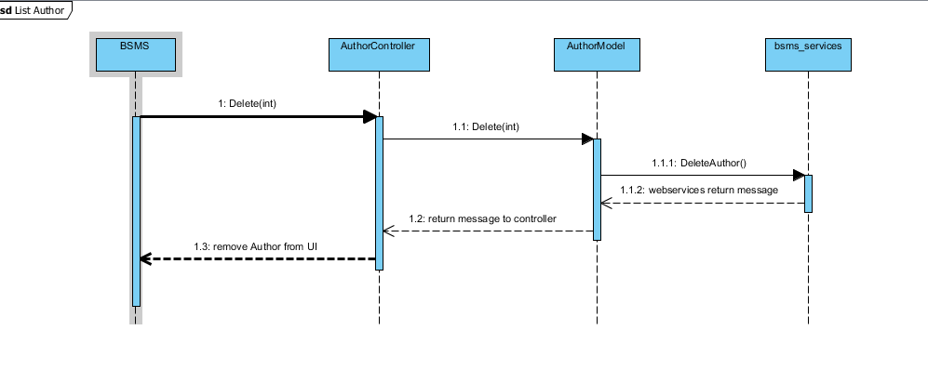

## Profile Management

### Class Diagram

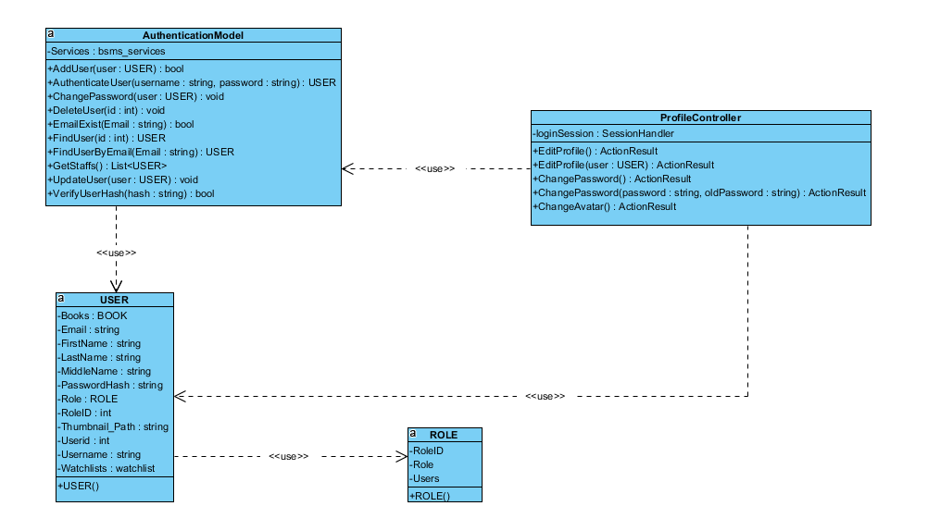

### Class Description

|  |  |  |
| --- | --- | --- |
| Class | Dependency | Description |
| User | Role | The user class holds all user data and information including all the usernames and passwords in the system, this is known as the BSMS user recognition methodology. |
| Role | N/A | This class is intended to hold unique set of roles for users, since the user uses this class as dependency, user has a role, which is how the system recognise the type of user coming into the system |
| ProfileController | N/A | This is a controller class that handles all operations that involving http Operations, once any corresponding http method is call the route engine fires up this controller by requesting it for action. |
| AuthenticationModel | USER | This is a class that handles all operations that involves Authentication including CRUD Operations, thus this class have direct connection to BSMS SOAP Webservices. |

#### User

|  |  |  |  |  |
| --- | --- | --- | --- | --- |
| Class | User | | | |
| **Description** | User data, this class holds all the user information including the password and username | | | |
| **Base Class** | Authentication | | | |
| **Constructor** | Default | | | |
| **Prototype** |  | | | |
| **Source File** | User.cs | | | |
| **Namespace** | BSMS.Model | | | |
| **Attributes** | Name | Type | Description | |
| Name | String | N/A | |
| Username | String | Users username is contained in this attribute | |
| PasswordHash | String | This contains 64 digit MD5 encrypted password | |
| Email | String |  | |
| RoleID | int | This hold the role of user in number format ex. (1:”Staff” , 2:”Admin”) | |
|  | Thumbnail | String | This hold the thumbnail path in the system | |
| **Methods** | Name | Input | Output | Description |
| Authentication | Username  Password | User | This function check if user is valid or not, returns null if not valid and user information if valid |
| LoggedOn | N/A | Boolean | This function is intended to check if any user is logged on to the system |

#### Role

|  |  |  |  |
| --- | --- | --- | --- |
| Class | Role | | |
| **Description** | This contain all the user roles that exists in the system | | |
| **Base Class** | N/A | | |
| **Constructor** | Default | | |
| **Prototype** |  | | |
| **Source File** | Role.cs | | |
| **Namespace** | BSMS.Model | | |
| **Attributes** | Name | Type | Description |
| Roleid | int | This is a unique integer value that holds a unique id for each role that exist in the system |
| Role | String | Role of this role e.g. (“Admin, Staff” .... ) |

#### ProfileController

|  |  |  |  |  |  |  |
| --- | --- | --- | --- | --- | --- | --- |
| Class | ProfileController | | | | | |
| **Description** | This class controls everything they deals with User and Roles | | | | | |
| **Base Class** | System.Web.Mvc.Controller | | | | | |
| **Constructor** | N/A | | | | | |
| **Prototype** |  | | | | | |
| **Source File** | ProfileController.cs | | | | | |
| **Namespace** | BSMS.Controller | | | | | |
| **Attributes** | Name | | Type | | Description | |
| loginSession | | SessionHandler | | This class acts as session assistant, in other words this class handles all session related activities | |
| **Methods** | Name | Input | | Output | | Description |
| EditProfile | N/A | | ActionResult | | This method make a request to the Http Get in order to request for edit profile page |
| EditProfile | USER | | ActionResult | | This method call makes request to Http Post and calls the Authentication Model class to update user detail |
| ChangePassword | N/A | | ActionResult | | This is http get method to display the change password page. |
| ChangePassword | String, String | | ActionResult | | This is http post method to change user password. |
| ChangeAvatar | HttpPostFileBase | | ActionResult | | Http Post that changes profile avatar. |

#### Authentication Model

|  |  |  |  |  |
| --- | --- | --- | --- | --- |
| Class | AuthenticationModel | | | |
| **Description** | This is a class that handles all operations that involves Authentication including CRUD Operations, thus this class have direct connection to BSMS SOAP Webservices. | | | |
| **Base Class** | N/A | | | |
| **Constructor** | Default | | | |
| **Prototype** |  | | | |
| **Source File** | Authentication.cs | | | |
| **Namespace** | BSMS.Model | | | |
| **Attributes** | Name | Type | Description | |
| Services | bsms\_services | This is a private instance of “BSMS.SERVICES” | |
| **Methods** | Name | Input | Output | Description |
| AddUser | USER | Boolean | This method is use to call the webservices method inorder to add a new user into the system |
| AuthenticateUser | String, String | USER | This method is proposed to check if login credential is correct or not, this return null if username or password is incorrect and User Object otherwise |
| ChangePassword | USER | N/A | This method is used to change user passwords on reset password request |
| DeleteUser | Int | N/A | This static method is used to delete user from BSMS |
| FindUser | Int | USER | This static method return User Object which matches the id of user inpt |
| FindUserByEmail | Int | USER | This method is used to find user by email, since the email address of each user is unique |
| GetStaffs | N/A | List<USER> | This method is used to get all avaliable staff in the system |
| UpdateStaff | USER | N/A | This is used to update staff information |
| VerifyUserHash | String | Boolean | This method is mainly used to verify hash code of users |

### Edit Profile

Adding staff in to the system is one of the many functionality that is only allowed of the admin user, which after the staff will be given some level of access to the system and allowed to perform some operations.

#### Screen Design

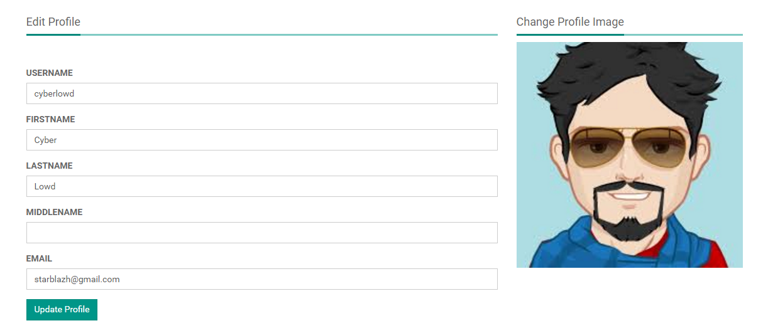

#### Sequence Diagram

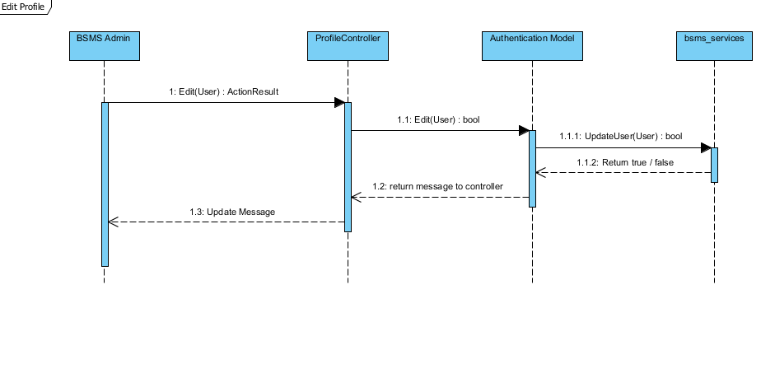

### Change Password

This functionality allow previously created staff to be edited if there exist any wrong information, editing information of staff including the name and other information e.g. changing staff first name from “Joe” to “John”

#### Screen Design

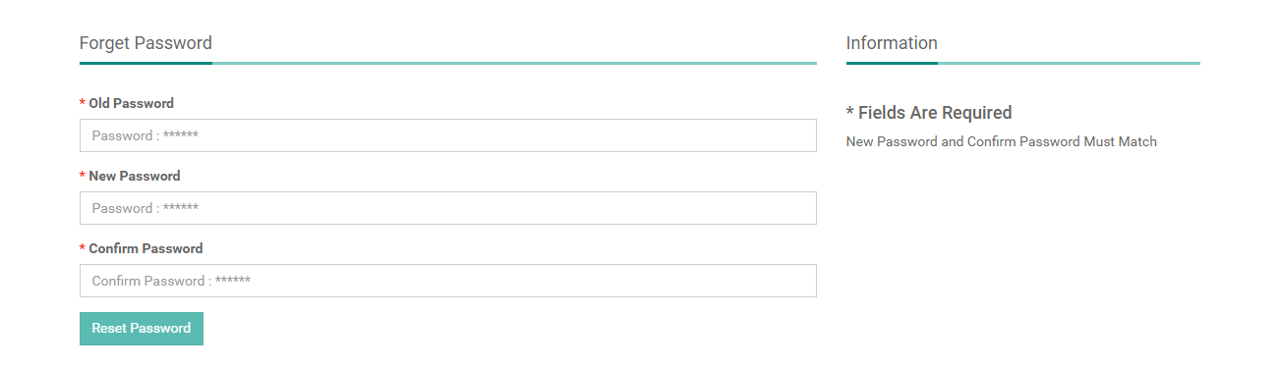

#### Sequence Diagram

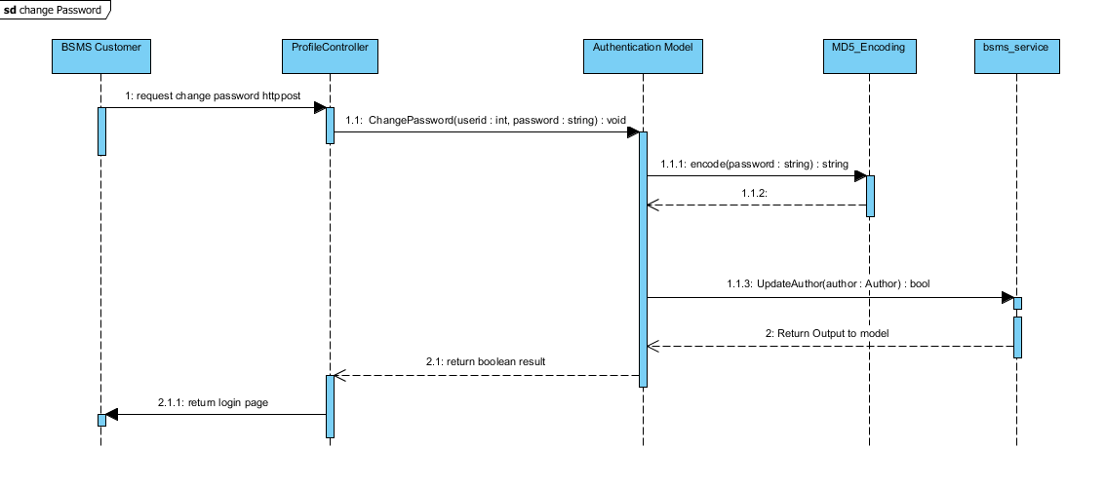

### Change Avatar

The list staff feature allow the admin use to view sequence staffs that have been added into the system, with each element of the sequence having edit, delete and info icon. On click of each icon triggers equivalent event for each element in that list.

#### Screen Design

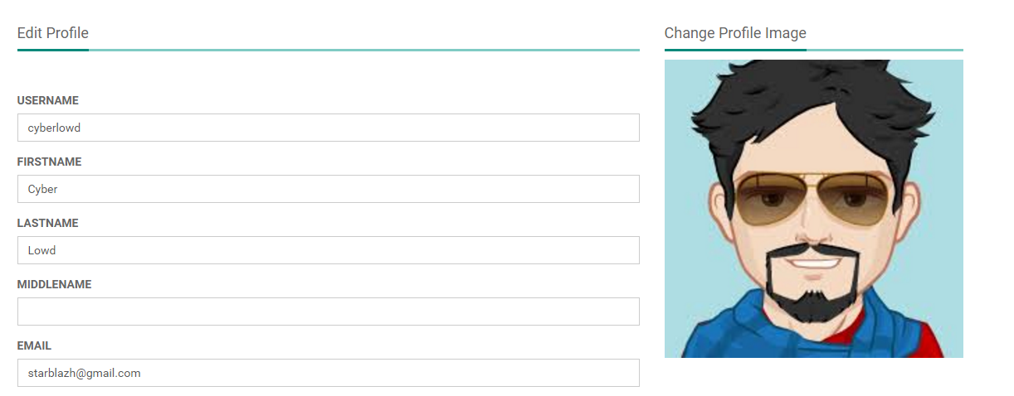

## System Search

### Class Diagram

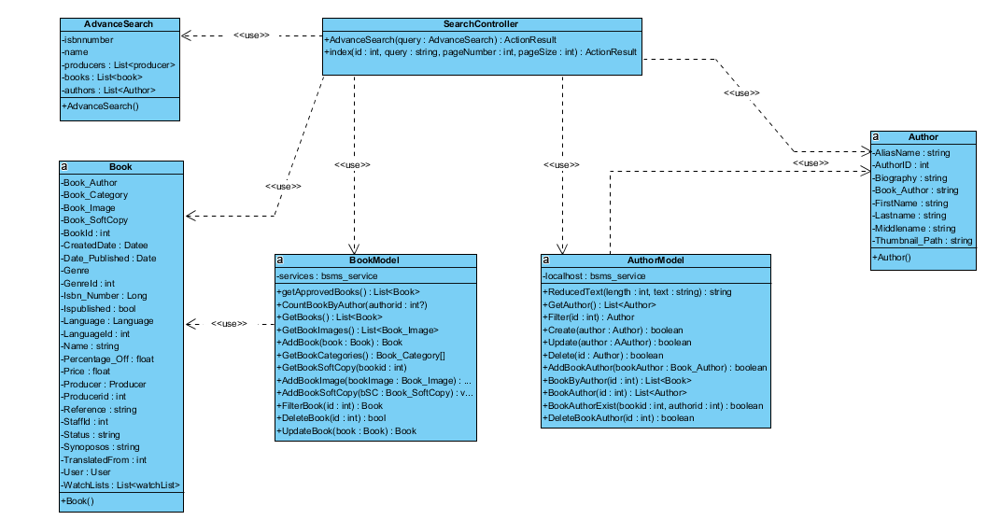

### Class Description

|  |  |  |
| --- | --- | --- |
| Class | Dependency | Description |
| AdvanceSearch | Role | The user class holds all user data and information including all the usernames and passwords in the system, this is known as the BSMS user recognition methodology. |
| Book | N/A | This class is intended to hold unique set of roles for users, since the user uses this class as dependency, user has a role, which is how the system recognise the type of user coming into the system |
| BookModel | N/A | This is a controller class that handles all operations that involving http Operations, once any corresponding http method is call the route engine fires up this controller by requesting it for action. |
| Author | N/A | This is an handler class that handles all session in the system, this class save and retrieves browsing session. |
| AuthorModel | USER | This is a class that handles all operations that involves Authentication including CRUD Operations, thus this class have direct connection to BSMS SOAP Webservices. |
| SearchController | N/A | This class handles system encryption, Md5 password encoding and decoding |

#### Search Controller

|  |  |  |  |  |
| --- | --- | --- | --- | --- |
| Class | StaffController | | | |
| **Description** | This class controls everything they deals with Search | | | |
| **Base Class** | System.Web.Mvc.Controller | | | |
| **Constructor** | N/A | | | |
| **Prototype** |  | | | |
| **Source File** | SearchController.cs | | | |
| **Namespace** | BSMS.Controller | | | |
| **Methods** | Name | Input | Output | Description |
| Index | Int, String, Int, Int | ActionResult | This method make a request to the Http Get in order to request for a page, this method handles simple search |
| AdvanceSearch | int | ActionResult | This method make a request to the Http Get in order to request for a page, this method handles Advance search |

#### AuthorModel

|  |  |  |  |  |
| --- | --- | --- | --- | --- |
| Class | AuthorModel | | | |
| **Description** | This class provide connection to BSMS SOAP services, CRUD operations will be handled by this model class | | | |
| **Base Class** | Object | | | |
| **Constructor** | Default | | | |
| **Prototype** |  | | | |
| **Source File** | AuthorModel.cs | | | |
| **Namespace** | BSMS.Model | | | |
| **Attributes** | Name | Type | Description | |
| localhost | Bsms\_services | A private instance of bsms soap web services | |
| **Methods** | Name | Input | Output | Description |
| ReducedText | Int , String | String | This method reduces string values to the number of length passed as parameter to it |
| GetAuthors | N/A | List<Author> | This helper method is used to get all record of author from the soap web services |
|  | Create | Author | Boolean | This helper method is used when creating a new author, which incase if parameter passed is valid then it performs the add functionality on bsms dastabase and returns true and false otherwise |
|  | Update | Author | Boolean | This helper method is used when updating an existing author, which incase if parameter passed is valid then it performs update functionality on bsms dastabase and returns true and false otherwise |
|  | Delete | Int | Boolean | this is a static internal type of method, which allows existing category to be deleted as the name Delete implies |
|  | AddBookAuthor | Book\_Author | Boolean | This helper method is used when creating a new book author, which incase if parameter passed is valid then it performs the add functionality on bsms dastabase and returns true and false otherwise |
|  | BookByAuthor | Int | List<Book> | This Author model static method takes as input, id of author and returns back to invoking class list of book written by the author, if author id is incorrect they system returns and empty list. |
|  | BookAuthor | Int | List<Author> | The static method takes as input id of book and returns back to the invoking parent a sequence of author which is the author that wrote the book |
|  | BookAuthorExist | Int, Int | Boolean | The main intention of creating this method in author is to verify if book author have previously exist in the system. This method takes in book id and author id and check if they exist or not, as the name implies. |
|  | DeleteBookAuthor | Int, Int | Boolean | This method carries out the delete operation for Book Author as a result of invoking this method, book author information that match the invoked parameters will be permanently delete from bsms. |

#### Author

|  |  |  |  |
| --- | --- | --- | --- |
| Class | Author | | |
| **Description** | This class provide connection to BSMS SOAP services, CRUD operations will be handled by this model class | | |
| **Base Class** | Object | | |
| **Constructor** | N/A | | |
| **Prototype** |  | | |
| **Source File** | Author.cs | | |
| **Namespace** | BSMS.bsms.localhost | | |
| **`** | Name | Type | Description |
| aliasName | Book | Author’s alias name |
| authorId | Int | Author’s unique identifier |
|  | biography | Int | Biography of author, this might contains the background history of this author. |
| Book\_author | String | This is a controller http post method that handles edit functionalities for genres |
|  | firstName | String | Author first name |
|  | lastName | String | Author last name |
|  | middleName | String | Author’s Middle name |
|  | Thumbnail\_path | String | Author image path in the web server |

#### BookModel

|  |  |  |  |  |
| --- | --- | --- | --- | --- |
| Class | bookModel | | | |
| **Description** | This class provide connection to BSMS SOAP services, CRUD operations will be handled by this model class | | | |
| **Base Class** | Object | | | |
| **Constructor** | Default | | | |
| **Prototype** |  | | | |
| **Source File** | BookModel.cs | | | |
| **Namespace** | BSMS.Model | | | |
| **Attributes** | Name | Type | Description | |
| service | Bsms\_services | A private instance of bsms soap web services | |
| **Methods** | Name | Input | Output | Description |
| GetApprovedBooks | N/A | List<Book> | This method query data from web services and return all books that have been approved |
| CountBookByAuthor | Int | Int | This helper method is used to get the amount of book that have been written by a particular author. |
|  | GetBooks | N/A | List<Book> | This model method main function is to get all books from the web service without filter |
|  | AddBook | Book | Boolean | Model method that performs add functionality into the system, by call the add book web method as describe in the web method description below |
|  | GetBookCategories | N/A | List<BookCategory> | This is a static internal type of method, which get all book categories from the web services without any filter added. |
|  | GetBookSoftCopy | N/A | List<Book\_SoftCopy> | This is a static internal type of method, which get all book book soft copy from the web services without any filter added. |
|  | AddBookImage | Book\_Image | Boolean | This Book model static method takes as input, the book image object and returns back to invoking parent Boolean result, if book image is successfully added in the system returns true and false otherwise. |
|  | AddBookSoftCopy | Book\_SoftCopy | Boolean | This Book model static method takes as input, the book soft copy object and returns back to invoking parent Boolean result, if object is successfully added in the system returns true and false otherwise. |
|  | FilterBook | Int | Book | The aim of this model method is to search for a particular book in the system, and returns book that match the given id, null otherwise |
|  | DeleteBook | Int | Boolean | This method carries out the delete operation for Book as a result of invoking this method, book information that match the invoked parameters will be permanently delete from bsms. |
|  | UpdateBook | Book | Boolean | This method carries out the update operation on book. As a result of invoking this method, book information that match the invoked parameters will be permanently updated and changes committed to bsms database. |

#### AdvanceSearch

|  |  |  |  |
| --- | --- | --- | --- |
| Class | AdvanceSearch | | |
| **Description** | This class contains list of books, author, producer and other information that are need in an advance search | | |
| **Base Class** | Object | | |
| **Constructor** | Default | | |
| **Prototype** |  | | |
| **Source File** | AdvanceSearch.cs | | |
| **Namespace** | BSMS.Entity | | |
| **Attributes** | Name | Type | Description |
| isbnnumber | int | This is a unique value for all books |
| name | String | This attribute contains the values of the searched keyword, it might be the name or description, synopsis, biography of a producer, book or author respectively. |
|  | producers | Int | This store the list of producers that match the given search criteria |
| books | string | This store the list of book that match the given search criteria |
|  | authors | int | This store the list of author that match the given search criteria |

#### Book

|  |  |  |  |
| --- | --- | --- | --- |
| Class | Book | | |
| **Description** | this class holds all book information including name, and synopsis | | |
| **Base Class** | Object | | |
| **Constructor** | Default | | |
| **Prototype** |  | | |
| **Source File** | Book.cs | | |
| **Namespace** | BSMS.bsms.localhost | | |
| **Attributes** | Name | Type | Description |
| Book\_Author | Book\_Author | Book author information |
| Book\_Category | Book\_Category | Book category information |
| Book\_Image | Book\_Image | Book image information |
| BookId | Int | This field contain the unique identifier for each book |
| CreatedDate | Date | Book created date time stamp |
|  | Date\_Published | Date | Book date publish time stamp |
|  | Genre | Genre | Book genre information |
|  | Genreid | Int | Book genre unique id |
|  | Isbn\_number | BigInt | Book isbn number |
|  | IsPublished | Boolean | Boolean value to confirm if book is published or not. |
|  | Language | Language | Book language object that stores the language the book is written in. |
|  | LanguageId | Int | Book language id |
|  | Name | String | Name of the book |
|  | Percentage\_Off | Float | Percentage off from the book |
|  | Price | Float | Unit / Original price of the book |
|  | Producer | Producer | Book producer information |
|  | ProducerId | Int | Book producer id |
|  | Reference | String | Web link that contains reference to the given book |
|  | StaffId | Int | Book staff id |
|  | Status | String | Book status “Approve” or “Not Approve” |
|  | Synopsis | String | Book synopsis information |
|  | TranslatedFrom | Int | Book translated from |
|  | User | User | This field store the id of the staff whom add this book into bsms |
|  | WatchLists | List<WatchList> | List of wishlist |

### Simple Search

The list staff feature allow the admin use to view sequence staffs that have been added into the system, with each element of the sequence having edit, delete and info icon. On click of each icon triggers equivalent event for each element in that list.

#### Screen Design



#### Sequence Diagram

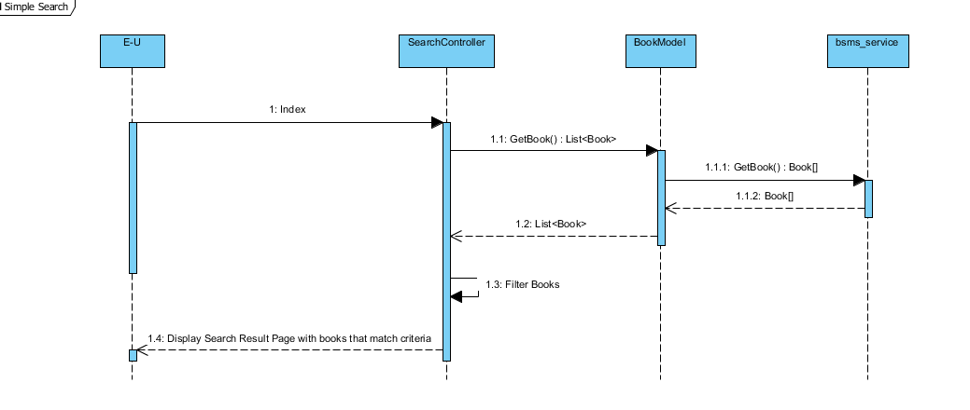

### Advance Search

This feature is only allowed of the admin users to delete staffs from the system, this feature is useful in the case where admin user added wrong/duplicate/unnecessary category, and this feature will allow admin to remit such mistake.

#### Screen Design

# Web Service API

## Web Service and Method

|  |  |
| --- | --- |
| Services | Operations |
| BSMS\_SERVICES | AddAuthor  AddUser  AddWishList  DeleteAuthor  DeleteBook  DeleteBookAuthor  DeleteBookCategory  DeleteBookImage  DeleteBookSoftCopy  DeleteCategory  DeleteGenre  DeleteProducer  DeleteUser  DeleteWishList  GetAllInJson  GetAllWishList  GetAuthors  GetBookAuthors  GetBookCategories  GetBookImages  GetBookSoftCopy  GetBooks  GetCategories  GetGenres  GetLanguages  GetProducers  GetRoles  GetUsers  GetWishList  InserCategory  InserGenre  InsertBook  InsertBookAuthor  InsertBookCategory  InsertBookImage  InsertBookSoftCopy  InsertProducer  UpdateAuthor  UpdateBook  UpdateBookAuthor  UpdateBookCategory  UpdateBookImage  UpdateBookSoftCopy  UpdateCategory  UpdateGenre  UpdateProducer  UpdateUser |

## Web Method Description

### AddAuthor

Insert a new Author into the bsms azure database

#### Parameters

|  |  |  |
| --- | --- | --- |
| Input Name | Parameters | Description |
| author | AUTHOR | Author’s information to be added. |

#### Response

|  |  |
| --- | --- |
| Output | Output Description |
| Boolean | Return true if the author is added into the database and false otherwise |

### AddUser

Insert a new User into the bsms azure database

#### Parameters

|  |  |  |
| --- | --- | --- |
| Input Name | Parameters | Description |
| user | USER | User information to be added. |

#### Response

|  |  |
| --- | --- |
| Output | Output Description |
| Boolean | Return true if the user is added into the database and false otherwise |

### AddWishList

Insert a new wish list into the bsms azure database

#### Parameters

|  |  |  |
| --- | --- | --- |
| Input Name | Parameters | Description |
| wishlist | WishList | This web method will be called when customers request to add a new wishlist to their account |

#### Response

|  |  |
| --- | --- |
| Output | Output Description |
| Boolean | Return true if the wishlish is added into the database and false otherwise |

### DeleteAuthor

Delete web method of bsms, this web method create permanent changes to the database, which cannot be reverted by any means once successful

#### Parameters

|  |  |  |
| --- | --- | --- |
| Input Name | Parameters | Description |
| authorid | Integer | This web method is meant to trigger delete action on the database, and if this method is triggered correctly and return true, permanent changes will be made to the database. |

#### Response

|  |  |
| --- | --- |
| Output | Output Description |
| Boolean | Return true if the author is removed from the database and false otherwise |

### DeleteBook

Delete web method of bsms, this web method create permanent changes to the database, which cannot be reverted by any means once successful

#### Parameters

|  |  |  |
| --- | --- | --- |
| Input Name | Parameters | Description |
| bookid | Integer | This web method is meant to trigger delete action on the database, and if this method is triggered correctly and return true, permanent changes will be made to the database. |

#### Response

|  |  |
| --- | --- |
| Output | Output Description |
| Boolean | Return true if the author is removed from the database and false otherwise |

### DeleteBookAuthor

Delete web method of bsms, this web method create permanent changes to the database, which cannot be reverted by any means once successful

#### Parameters

|  |  |  |
| --- | --- | --- |
| Input Name | Parameters | Description |
| Book\_authorid | Integer | This web method is meant to trigger delete action on the database, and if this method is triggered correctly and return true, permanent changes will be made to the database. |

#### Response

|  |  |
| --- | --- |
| Output | Output Description |
| Boolean | Return true if the author is removed from the database and false otherwise |

### DeleteBookCategory

Delete web method of bsms, this web method create permanent changes to the database, which cannot be reverted by any means once successful

#### Parameters

|  |  |  |
| --- | --- | --- |
| Input Name | Parameters | Description |
| Book\_category | Integer | This web method is meant to trigger delete action on the database, and if this method is triggered correctly and return true, permanent changes will be made to the database. |

#### Response

|  |  |
| --- | --- |
| Output | Output Description |
| Boolean | Return true if the author is removed from the database and false otherwise |

### DeleteBookImage

Delete web method of bsms, this web method create permanent changes to the database, which cannot be reverted by any means once successful

#### Parameters

|  |  |  |
| --- | --- | --- |
| Input Name | Parameters | Description |
| Book\_imageid | Integer | This web method is meant to trigger delete action on the database, and if this method is triggered correctly and return true, permanent changes will be made to the database. |

#### Response

|  |  |
| --- | --- |
| Output | Output Description |
| Boolean | Return true if the author is removed from the database and false otherwise |

### DeleteBookSoftCopy

Delete web method of bsms, this web method create permanent changes to the database, which cannot be reverted by any means once successful

#### Parameters

|  |  |  |
| --- | --- | --- |
| Input Name | Parameters | Description |
| Book\_softcopy\_id | Integer | This web method is meant to trigger delete action on the database, and if this method is triggered correctly and return true, permanent changes will be made to the database. |

#### Response

|  |  |
| --- | --- |
| Output | Output Description |
| Boolean | Return true if the author is removed from the database and false otherwise |

### DeleteCategory

Delete web method of bsms, this web method create permanent changes to the database, which cannot be reverted by any means once successful

#### Parameters

|  |  |  |
| --- | --- | --- |
| Input Name | Parameters | Description |
| categoryid | Integer | This web method is meant to trigger delete action on the database, and if this method is triggered correctly and return true, permanent changes will be made to the database. |

#### Response

|  |  |
| --- | --- |
| Output | Output Description |
| Boolean | Return true if the author is removed from the database and false otherwise |

### DeleteGenre

Delete web method of bsms, this web method create permanent changes to the database, which cannot be reverted by any means once successful

#### Parameters

|  |  |  |
| --- | --- | --- |
| Input Name | Parameters | Description |
| genreid | Integer | This web method is meant to trigger delete action on the database, and if this method is triggered correctly and return true, permanent changes will be made to the database. |

#### Response

|  |  |
| --- | --- |
| Output | Output Description |
| Boolean | Return true if the author is removed from the database and false otherwise |

### DeleteProducer

Delete web method of bsms, this web method create permanent changes to the database, which cannot be reverted by any means once successful

#### Parameters

|  |  |  |
| --- | --- | --- |
| Input Name | Parameters | Description |
| producerid | Integer | This web method is meant to trigger delete action on the database, and if this method is triggered correctly and return true, permanent changes will be made to the database. |

#### Response

|  |  |
| --- | --- |
| Output | Output Description |
| Boolean | Return true if the author is removed from the database and false otherwise |

### DeleteUser

Delete web method of bsms, this web method create permanent changes to the database, which cannot be reverted by any means once successful

#### Parameters

|  |  |  |
| --- | --- | --- |
| Input Name | Parameters | Description |
| userid | Integer | This web method is meant to trigger delete action on the database, and if this method is triggered correctly and return true, permanent changes will be made to the database. |

#### Response

|  |  |
| --- | --- |
| Output | Output Description |
| Boolean | Return true if the author is removed from the database and false otherwise |

### DeleteWishList

Delete web method of bsms, this web method create permanent changes to the database, which cannot be reverted by any means once successful

#### Parameters

|  |  |  |
| --- | --- | --- |
| Input Name | Parameters | Description |
| wishlistid | Integer | This web method is meant to trigger delete action on the database, and if this method is triggered correctly and return true, permanent changes will be made to the database. |

#### Response

|  |  |
| --- | --- |
| Output | Output Description |
| Boolean | Return true if the author is removed from the database and false otherwise |

### GetAllWishList

Get web method bsms services, this have no input parameter and returns sequence of initialised entities values

#### Parameters

|  |  |  |
| --- | --- | --- |
| Input Name | Parameters | Description |
| N/A | N/A | N/A |

#### Response

|  |  |
| --- | --- |
| Output | Output Description |
| List<WishList> | List of wishlist is an ordered sequence of wishlist sort according to the natural order, which is the order in which they were added into bsms db. |

### GetAuthors

Get web method bsms services, this have no input parameter and returns sequence of initialised entities values

#### Parameters

|  |  |  |
| --- | --- | --- |
| Input Name | Parameters | Description |
| N/A | N/A | N/A |

#### Response

|  |  |
| --- | --- |
| Output | Output Description |
| List<Author> | List of author is an ordered sequence of authors sort according to the natural order, which is the order in which they were added into bsms db. |

### GetBookAuthors

Get web method bsms services, this have no input parameter and returns sequence of initialised entities values

#### Parameters

|  |  |  |
| --- | --- | --- |
| Input Name | Parameters | Description |
| N/A | N/A | N/A |

#### Response

|  |  |
| --- | --- |
| Output | Output Description |
| List<BookAuthor> | List of book author is an ordered sequence of book sort according to the natural order, which is the order in which they were added into bsms db. |

### GetBookCategories

Get web method bsms services, this have no input parameter and returns sequence of initialised entities values

#### Parameters

|  |  |  |
| --- | --- | --- |
| Input Name | Parameters | Description |
| N/A | N/A | N/A |

#### Response

|  |  |
| --- | --- |
| Output | Output Description |
| List<BookCategory > | List of book category is an ordered sequence of book category sort according to the natural order, which is the order in which they were added into bsms db. |

### GetBookImages

Get web method bsms services, this have no input parameter and returns sequence of initialised entities values

#### Parameters

|  |  |  |
| --- | --- | --- |
| Input Name | Parameters | Description |
| N/A | N/A | N/A |

#### Response

|  |  |
| --- | --- |
| Output | Output Description |
| List<BookImage> | List of book image is an ordered sequence of book image sort according to the natural order, which is the order in which they were added into bsms db. |

### GetBookSoftCopy

Get web method bsms services, this have no input parameter and returns sequence of initialised entities values

#### Parameters

|  |  |  |
| --- | --- | --- |
| Input Name | Parameters | Description |
| N/A | N/A | N/A |

#### Response

|  |  |
| --- | --- |
| Output | Output Description |
| List<BookSoftCopy> | List of book soft copy is an ordered sequence of book soft copy sort according to the natural order, which is the order in which they were added into bsms db. |

### GetBooks

Get web method bsms services, this have no input parameter and returns sequence of initialised entities values

#### Parameters

|  |  |  |
| --- | --- | --- |
| Input Name | Parameters | Description |
| N/A | N/A | N/A |

#### Response

|  |  |
| --- | --- |
| Output | Output Description |
| List<Book> | List of book is an ordered sequence of book sort according to the natural order, which is the order in which they were added into bsms db. |

### GetCategories

Get web method bsms services, this have no input parameter and returns sequence of initialised entities values

#### Parameters

|  |  |  |
| --- | --- | --- |
| Input Name | Parameters | Description |
| N/A | N/A | N/A |

#### Response

|  |  |
| --- | --- |
| Output | Output Description |
| List<Category> | List of category is an ordered sequence of book sort according to the natural order, which is the order in which they were added into bsms db. |

### GetGenres

Get web method bsms services, this have no input parameter and returns sequence of initialised entities values

#### Parameters

|  |  |  |
| --- | --- | --- |
| Input Name | Parameters | Description |
| N/A | N/A | N/A |

#### Response

|  |  |
| --- | --- |
| Output | Output Description |
| List<Genre> | List of genre is an ordered sequence of genre sort according to the natural order, which is the order in which they were added into bsms db. |

### GetLanguages

Get web method bsms services, this have no input parameter and returns sequence of initialised entities values

#### Parameters

|  |  |  |
| --- | --- | --- |
| Input Name | Parameters | Description |
| N/A | N/A | N/A |

#### Response

|  |  |
| --- | --- |
| Output | Output Description |
| List<Language> | List of language is an ordered sequence of language sort according to the natural order, which is the order in which they were added into bsms db. |

### GetProducers

Get web method bsms services, this have no input parameter and returns sequence of initialised entities values

#### Parameters

|  |  |  |
| --- | --- | --- |
| Input Name | Parameters | Description |
| N/A | N/A | N/A |

#### Response

|  |  |
| --- | --- |
| Output | Output Description |
| List<Producer> | List of producer is an ordered sequence of producer sort according to the natural order, which is the order in which they were added into bsms db. |

### GetRoles

Get web method bsms services, this have no input parameter and returns sequence of initialised entities values

#### Parameters

|  |  |  |
| --- | --- | --- |
| Input Name | Parameters | Description |
| N/A | N/A | N/A |

#### Response

|  |  |
| --- | --- |
| Output | Output Description |
| List<Book> | List of role is an ordered sequence of role sort according to the natural order, which is the order in which they were added into bsms db. |

### GetUsers

Get web method bsms services, this have no input parameter and returns sequence of initialised entities values

#### Parameters

|  |  |  |
| --- | --- | --- |
| Input Name | Parameters | Description |
| N/A | N/A | N/A |

#### Response

|  |  |
| --- | --- |
| Output | Output Description |
| List<User> | List of user is an ordered sequence of user sorted according to the natural order, which is the order in which they were added into bsms db. |

### GetWishList

Get web method bsms services, this have no input parameter and returns sequence of initialised entities values

#### Parameters

|  |  |  |
| --- | --- | --- |
| Input Name | Parameters | Description |
| UserID | Integer | N/A |

#### Response

|  |  |
| --- | --- |
| Output | Output Description |
| List<WishList> | This web method return wish list that belongs to a particular user which id is input, and returns null if the user id is invalid or does not exist. |

### InsertCategory

Insert method of bsms services, this method handles insert functions, this web method communicate with bsms database using the linq to sql.

#### Parameters

|  |  |  |
| --- | --- | --- |
| Input Name | Parameters | Description |
| Category | Category | This web method accept category object as parameter, which as a result will be added into the database |

#### Response

|  |  |
| --- | --- |
| Output | Output Description |
| Boolean | This web method return Boolean result, true if the soap service method run under a normal case which as a result have been added into the database and false otherwise. |

### InserGenre

Insert method of bsms services, this method handles insert functions, this web method communicate with bsms database using the linq to sql.

#### Parameters

|  |  |  |
| --- | --- | --- |
| Input Name | Parameters | Description |
| Genre | Genre | This web method accept genre object as parameter, which as a result will be added into the database |

#### Response

|  |  |
| --- | --- |
| Output | Output Description |
| Boolean | This web method return Boolean result, true if the soap service method run under a normal case which as a result have been added into the database and false otherwise. |

### InsertBook

Insert method of bsms services, this method handles insert functions, this web method communicate with bsms database using the linq to sql.

#### Parameters

|  |  |  |
| --- | --- | --- |
| Input Name | Parameters | Description |
| book | Book | This web method accept book object as parameter, which as a result will be added into the database |

#### Response

|  |  |
| --- | --- |
| Output | Output Description |
| Boolean | This web method return Boolean result, true if the soap service method run under a normal case which as a result have been added into the database and false otherwise. |

### InsertBookAuthor

Insert method of bsms services, this method handles insert functions, this web method communicate with bsms database using the linq to sql.

#### Parameters

|  |  |  |
| --- | --- | --- |
| Input Name | Parameters | Description |
| bookAuthor | BookAuthor | This web method accept book author object as parameter, which as a result will be added into the database |

#### Response

|  |  |
| --- | --- |
| Output | Output Description |
| Boolean | This web method return Boolean result, true if the soap service method run under a normal case which as a result have been added into the database and false otherwise. |

### InsertBookImage

Insert method of bsms services, this method handles insert functions, this web method communicate with bsms database using the linq to sql.

#### Parameters

|  |  |  |
| --- | --- | --- |
| Input Name | Parameters | Description |
| bookImage | BookImage | This web method accept book image object as parameter, which as a result will be added into the database |

#### Response

|  |  |
| --- | --- |
| Output | Output Description |
| Boolean | This web method return Boolean result, true if the soap service method run under a normal case which as a result have been added into the database and false otherwise. |

### InsertBookSoftCopy

Insert method of bsms services, this method handles insert functions, this web method communicate with bsms database using the linq to sql.

#### Parameters

|  |  |  |
| --- | --- | --- |
| Input Name | Parameters | Description |
| bookSoftCopy | BookSoftCopy | This web method accept book soft copy object as parameter, which as a result will be added into the database |

#### Response

|  |  |
| --- | --- |
| Output | Output Description |
| Boolean | This web method return Boolean result, true if the soap service method run under a normal case which as a result have been added into the database and false otherwise. |

### InsertProducer

Insert method of bsms services, this method handles insert functions, this web method communicate with bsms database using the linq to sql.

#### Parameters

|  |  |  |
| --- | --- | --- |
| Input Name | Parameters | Description |
| Producer | Producer | This web method accept producer object as parameter, which as a result will be added into the database |

#### Response

|  |  |
| --- | --- |
| Output | Output Description |
| Boolean | This web method return Boolean result, true if the soap service method run under a normal case which as a result have been added into the database and false otherwise. |

### UpdateAuthor

Update web method of bsms that handles edit functionality for its equivalent entities, this web method makes permanent changes to the database and such changes cannot be reverted by any means.

#### Parameters

|  |  |  |
| --- | --- | --- |
| Input Name | Parameters | Description |
| Author | author | This web method accept author object as parameter, which as a result will be update and changes made to the database |

#### Response

|  |  |
| --- | --- |
| Output | Output Description |
| Boolean | This web method return Boolean result, true if the soap service method run under a normal case which as a result have been added into the database and false otherwise. |

### UpdateBook

Update web method of bsms that handles edit functionality for its equivalent entities, this web method makes permanent changes to the database and such changes cannot be reverted by any means.

#### Parameters

|  |  |  |
| --- | --- | --- |
| Input Name | Parameters | Description |
| Book | book | This web method accept book object as parameter, which as a result will be update and changes made to the database |

#### Response

|  |  |
| --- | --- |
| Output | Output Description |
| Boolean | This web method return Boolean result, true if the soap service method run under a normal case which as a result have been added into the database and false otherwise. |

### UpdateBookAuthor

Update web method of bsms that handles edit functionality for its equivalent entities, this web method makes permanent changes to the database and such changes cannot be reverted by any means.

#### Parameters

|  |  |  |
| --- | --- | --- |
| Input Name | Parameters | Description |
| bAuthor | Book\_Author | This web method accept book author object as parameter, which as a result will be update and changes made to the database |

#### Response

|  |  |
| --- | --- |
| Output | Output Description |
| Boolean | This web method return Boolean result, true if the soap service method run under a normal case which as a result have been added into the database and false otherwise. |

### UpdateBookCategory

Update web method of bsms that handles edit functionality for its equivalent entities, this web method makes permanent changes to the database and such changes cannot be reverted by any means.

#### Parameters

|  |  |  |
| --- | --- | --- |
| Input Name | Parameters | Description |
| BookCategory | Book\_Category | This web method accept book category object as parameter, which as a result will be update and changes made to the database |

#### Response

|  |  |
| --- | --- |
| Output | Output Description |
| Boolean | This web method return Boolean result, true if the soap service method run under a normal case which as a result have been added into the database and false otherwise. |

### UpdateBookImage

Update web method of bsms that handles edit functionality for its equivalent entities, this web method makes permanent changes to the database and such changes cannot be reverted by any means.

#### Parameters

|  |  |  |
| --- | --- | --- |
| Input Name | Parameters | Description |
| BookImage | Book\_Image | This web method accept book image object as parameter, which as a result will be update and changes made to the database |

#### Response

|  |  |
| --- | --- |
| Output | Output Description |
| Boolean | This web method return Boolean result, true if the soap service method run under a normal case which as a result have been added into the database and false otherwise. |

### UpdateBookSoftCopy

Update web method of bsms that handles edit functionality for its equivalent entities, this web method makes permanent changes to the database and such changes cannot be reverted by any means.

#### Parameters

|  |  |  |
| --- | --- | --- |
| Input Name | Parameters | Description |
| BookSoftCopy | Book\_SoftCopy | This web method accept book soft copy object as parameter, which as a result will be update and changes made to the database |

#### Response

|  |  |
| --- | --- |
| Output | Output Description |
| Boolean | This web method return Boolean result, true if the soap service method run under a normal case which as a result have been added into the database and false otherwise. |

### UpdateGenre

Update web method of bsms that handles edit functionality for its equivalent entities, this web method makes permanent changes to the database and such changes cannot be reverted by any means.

#### Parameters

|  |  |  |
| --- | --- | --- |
| Input Name | Parameters | Description |
| Genre | Genre | This web method accept genre object as parameter, which as a result will be update and changes made to the database |

#### Response

|  |  |
| --- | --- |
| Output | Output Description |
| Boolean | This web method return Boolean result, true if the soap service method run under a normal case which as a result have been added into the database and false otherwise. |

### UpdateProducer

Update web method of bsms that handles edit functionality for its equivalent entities, this web method makes permanent changes to the database and such changes cannot be reverted by any means.

#### Parameters

|  |  |  |
| --- | --- | --- |
| Input Name | Parameters | Description |
| Producer | Producer | This web method accept producer object as parameter, which as a result will be update and changes made to the database |

#### Response

|  |  |
| --- | --- |
| Output | Output Description |
| Boolean | This web method return Boolean result, true if the soap service method run under a normal case which as a result have been added into the database and false otherwise. |

### UpdateUser

Update web method of bsms that handles edit functionality for its equivalent entities, this web method makes permanent changes to the database and such changes cannot be reverted by any means.

#### Parameters

|  |  |  |
| --- | --- | --- |
| Input Name | Parameters | Description |
| User | User | This web method accept user object as parameter, which as a result will be update and changes made to the database |

#### Response

|  |  |
| --- | --- |
| Output | Output Description |
| Boolean | This web method return Boolean result, true if the soap service method run under a normal case which as a result have been added into the database and false otherwise. |

# DATABASE DESIGN

## Entity Relationship Diagram

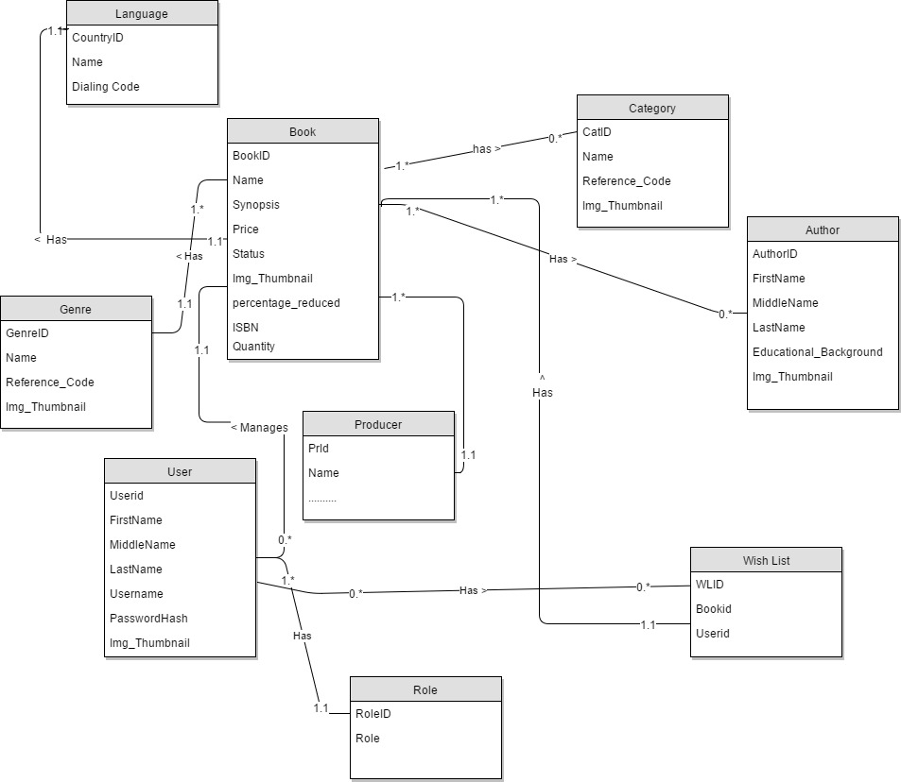

## Database Diagram



## Table Descriptions

### User

|  |  |  |  |  |
| --- | --- | --- | --- | --- |
| No. | Attribute | Type | Constraints | Description |
| 1 | USERID | INT | Primary key | User’s unique identifier |
| 2 | USERNAME | VARCHAR | Not null |  |
| 3 | PASSWORDHASH | VARCHAR | Not Null | This contains the password hash of users in MD5 format |
| 4 | FIRSTNAME | VARCHAR | Not null | User’s name |
| 5 | LASTNAME | VARCHAR | N/A | User’s name |
| 6 | MIDDLENAME | VARCHAR | N/A | User’s name |
| 7 | THUMBNAIL\_PATH | VARCHAR |  | This attribute contains user’s image path |
| `8 | EMAIL | VARCHAR | Not null | User’s unique email address |
| 9 | ROLEID | INT | Foreign Key | Role foreign key, this is how the system recognise different type of users |

### Role

|  |  |  |  |  |
| --- | --- | --- | --- | --- |
| No. | Attribute | Type | Constraints | Description |
| 1 | ROLEID | INT | Primary Key | Role unique identifier, auto increment field |
| 2 | ROLE | VARCHAR | Not Null | Role name |

### Author

|  |  |  |  |  |
| --- | --- | --- | --- | --- |
| No. | Attribute | Type | Constraints | Description |
| 1 | AUTHORID | INT | Primary Key | Author unique identifier, auto increment field |
| 2 | FIRSTNAME | VARCHAR | Not null | Author’s First name |
| 3 | LASTNAME | VARCHAR | Not Null | Author’s Last name |
| 4 | MIDDLENAME | VARCHAR | N/A | Author’s Middle name |
| 5 | BIOGRAPHY | VARCHAR | Not null | Full detail about author |
| 6 | ALIASNAME | VARCHAR | N/A | Author’s nick, prefix or any name the is popularly use to refer to such author |
| 7 | THUMBNAIL\_PATH | VARCHAR | Not Null | Image path of author is store in this attribute |

### Category

|  |  |  |  |  |
| --- | --- | --- | --- | --- |
| No. | Attribute | Type | Constraints | Description |
| 1 | CATEGORYID | INT | Primary Key | Category unique identifier, auto increment field |
| 2 | NAME | VARCHAR | Not null | Category name |
| 3 | DESCRIPTION | VARCHAR | Not null | Category description |
| 4 | REFERENCE\_KEY | VARCHAR | N/A | The reference key set the link to each category |
| 5 | CATEGORY\_THUMBNAIL | VARCHAR | Not Null | Image path of category is store in this attribute |

### Genre

|  |  |  |  |  |
| --- | --- | --- | --- | --- |
| No. | Attribute | Type | Constraints | Description |
| 1 | GENREID | INT | Primary Key | Genre unique identifier, auto increment field |
| 2 | NAME | VARCHAR | Not null | Genre name |
| 3 | DESCRIPTION | VARCHAR | Not null | Genre description |
| 4 | REFERENCE\_KEY | VARCHAR | N/A | The reference key set the link to each Genre |

### Book

|  |  |  |  |  |
| --- | --- | --- | --- | --- |
| No. | Attribute | Type | Constraints | Description |
| 1 | BOOKID | INT | Primary Key | Book unique identifier, auto increment field |
| 2 | ISBN\_NUMBER | BIGINT | Not null | Unique book identifier |
| 3 | NAME | VARCHAR | Not null | Book name |
| 4 | THUMBNAIL\_PATH | VARCHAR | N/A | Book image path address |
| 5 | STATUS | BIT | Null | Book status Null = “Not attended”, 0 = “Rejected” and 1=”Approved” |
| 6 | ISPUBLISHED | BIT | Not Null |  |
| 7 | SYNOPOSIS | VARCHAR | Not null | this holds information of book overview. |
| 8 | REFERENCE | VARCHAR | N/A | This contains information all available references |
| 9 | DATE\_PUBLISHED | DATETIME | N/A | Date this book was published, normally the date admin approves the book |
| 10 | CREATED\_DATE | DATETIME | N/A | Date this book was initially created |
| 11 | PRICE | FLOAT | Not null | Price of this book |
| 12 | PERCENTAGE\_OFF | INT | null | Percentage discount |
| 13 | GENREID | INT | Foreign Key | Book genre |
| 14 | STAFFID | INT | Foreign Key | Staff who controls this book |
| 15 | PRODUCERID | INT | Foreign Key | Producer of this book |
| 16 | LANGUAGEID | INT | Foreign Key | Language id of the language this book is written in. |

### Book\_Category

|  |  |  |  |  |
| --- | --- | --- | --- | --- |
| No. | Attribute | Type | Constraints | Description |
| 1 | BOOK\_CATEGORYID | INT | Primary Key | Book category unique identifier |
| 2 | BOOKID | INT | Foreign Key | Book id references |
| 3 | CATEGORYID | INT | Foreign Key | Category id references |

### Producer

|  |  |  |  |  |
| --- | --- | --- | --- | --- |
| No. | Attribute | Type | Constraints | Description |
| 1 | PRODUCTID | INT | Primary Key |  |
| 2 | NAME | INT | Not Null |  |
| 3 | ADDRESS | INT | Not Null |  |
| 4 | CONTACT | VARCHAR | Null |  |
| 5 | EMAIL | VARCHAR | Null |  |

### Book\_SoftCopy

|  |  |  |  |  |
| --- | --- | --- | --- | --- |
| No. | Attribute | Type | Constraints | Description |
| 1 | BSCID | INT | Primary Key |  |
| 2 | BOOKID | INT | Foreign Key |  |
| 3 | VERSION | FLOAT | Not Null |  |
| 4 | FILEPATH | VARCHAR | Null |  |
| 5 | FILESIZE | INT | Null |  |

### Book\_Author

|  |  |  |  |  |
| --- | --- | --- | --- | --- |
| No. | Attribute | Type | Constraints | Description |
| 1 | BOOK\_AUTHORID | INT | Primary Key |  |
| 2 | BOOKID | INT | Foreign Key |  |
| 3 | AUTHORID | INT | Foreign Key |  |

### WatchList

|  |  |  |  |  |
| --- | --- | --- | --- | --- |
| No. | Attribute | Type | Constraints | Description |
| 1 | WATCHLISTID | INT | Primary Key |  |
| 2 | BOOKID | INT | Foreign Key |  |
| 3 | USERID | INT | Foreign Key |  |

### BOOK\_IMAGE

|  |  |  |  |  |
| --- | --- | --- | --- | --- |
| No. | Attribute | Type | Constraints | Description |
| 1 | BOOK\_IMAGEID | INT | Primary Key | Book image unique identifier |
| 2 | BOOKID | INT | Foreign Key | Book unique id (Identity) foreign key references |
| 3 | IMAGEPATH | VARCHAR | N/A | Server location of image |

### LANGUAGE

|  |  |  |  |  |
| --- | --- | --- | --- | --- |
| No. | Attribute | Type | Constraints | Description |
| 1 | LANGUAGEID | INT | Primary Key | Language unique identifier |
| 2 | LANGUAGE | VARCHAR(20) | N/A | Language name |